**Github link: https://github.com/jagadeeshd146/Milestone2**

**E. Conceptual & logical model: identify all entity sets, write each relationship between entity sets as two sentences, add attributes to entity sets, write the functional dependencies, replace multi-attribute keys with surrogate keys, perform the normalization analysis and correct normalization problems, draw the ERD that shows the entity sets and their relationships**

The Entities of the Conceptual and Logical model are:

* Coach_details
* Team
* Players
* Match
* Umpire
* Stadium
* Sponsor
* Ticket_details

**The relationships between entity sets:**

There are mainly one-to-many and many-to-one relationships in the ERD diagram.

coach_details to Team: Each coach belongs to one team but a team can have multiple coaches.

Team to Players: A team can have multiple players. Each player belongs to a single team.

coach_details to Match: Each match is connected with a coach but each coach can be connected or associated with different matches.

Match to umpire: Each match has multiple umpires but each umpire can supervise several matches.

Match to Stadium: Each stadium hosts multiple matches but each match is hosted in a stadium.

Stadium to Sponsors: Each stadium is sponsored by multiple sponsors. A sponsor can sponsor multiple stadiums.

Sponsors to Ticket_details: Each sponsor is associated with a specific type of ticket. Multiple sponsors can be associated with different types of tickets.

**Attributes:**

The attributes present in the diagram are,

* Coach_details (coach_id, Nationality, Name, Team_id)
* Team (Team_id, Team_name, Total_players, Team_ranking)
* Player (player_id, player_name, nationality, Player_type, Team_id)
* Match (match_id, Team1, Team2, Winner, Run_score, coach_id)
* Umpire (umpire_id, umpire_name, nationality, umpire_rank, match_id)
* Stadium (Stadium_id, Stadium_name, location, Sponsor_id, match_id)
* Sponsors (Sponsors_id, Sponsor_name, Total_distributed_amount, Ticket_id)
* Ticket_ details (Ticket_id, Ticket_type, Qty, Price)

**Functional Dependencies:**

* Coach_details (coach_id → nationality, name)
* Team (team_id → team_name, total_players, team_ranking)
* Player (player_id → player_name, nationality, player_type)
* Player (team_id → player_id)
* Match (match_id → Team1, Team2, Winner, Run_score, coach_id)
* Umpire (umpire_id → umpire_name, nationality, umpire_rank)
* Umpire (match_id → umpire_id)
* Stadium (Stadium_id → Stadium_name, location)
* Sponsor (sponsor_id → Sponsor_name, Total_distributed_amount)
* Sponsor (match_id → Sponsor_id)
* Ticket (Ticket_id → Ticket_type, Qty, Price)
* Ticket (match_id → ticket_id)

**Normalization analysis:**

1. All the tables contain atomic values. Therefore they are in 1NF.
2. There are no partial dependencies in any table. Therefore they are in 2NF.
3. Though there are some transitive dependencies present in some tables. So, they are in 3NF.
4. In the ‘Match’ table, ‘coach_id’ relies on ‘match_id’, which is not a primary key. It is a non-prime attribute. To achieve 3NF, we need to erase the dependency of ‘coach_id’ on ‘match_id’.
5. Again in the ‘Stadium’ table, ‘Sponsors_id’ relies on ‘Stadium_id’. ‘Stadium_id’ is not a primary key. Rather it is a non-prime attribute. For achieving 3NF, it requires removing the dependency of ‘Sponsors_id’ on ‘Stadium_id’.

**Correction of Normalization Problems:**

For achieving 3NF and the correction of normalization problems, it requires to do the following:

1. Creating a new table for ‘Match_coach_deatils’ with ‘match_id’ as the primary key and ‘coach_id’ as a foreign key.
2. Creating a new table for ‘Stadium_Sponsors’ with ‘Stadium_id’ as the primary key and ‘Sponsors_id’ as a foreign key.

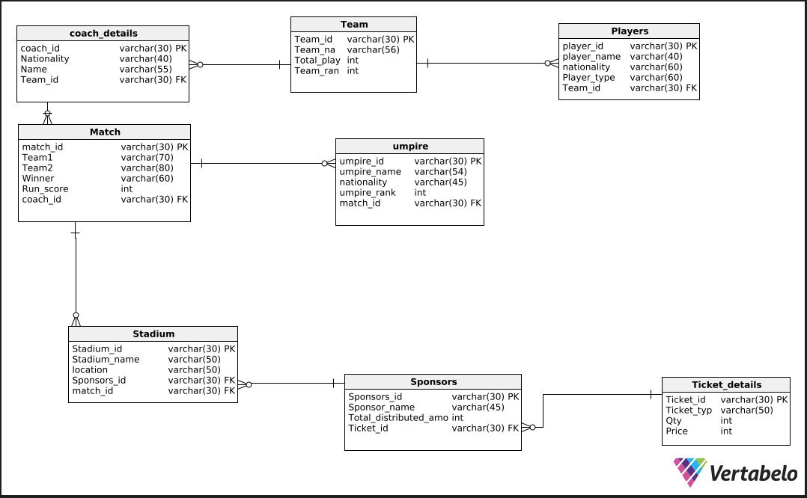

**F. Physical model: replace all M:N relationships with bridge entity sets, clearly define all attributes' data types (including sizes), draw the ERD for the physical model that is free of errors (Vertabelo shows you the errors), generate the SQL needed to build the database, and then build the database, showing screen shots that prove that the database exists on your system. Use the command "show tables;" to show a list of the tables in the database, and then use "describe" along with each table name to show the columns in each table you created.**

**SQL generation to build the database:**

* First, we need to draw the diagram
* Then it needs to click the Generate SQL Script icon in the top bar
* Then the next step is clicking the Generate option
* Then click the SQL file button in the main toolbar
* After that, we need to choose whether we want to generate a Create or Drop script
* Next, we identify which elements should be included in it
* We click Generate
* Then clicking the Download button to save this file.

**Building the database:**

* First I opened XAMPP
* It launched the Apache Server and MySQL Database
* I create a database via phpMyAdmin
* I chose the SQL file which I exported from Vertabelo
* I then import it in xammp.

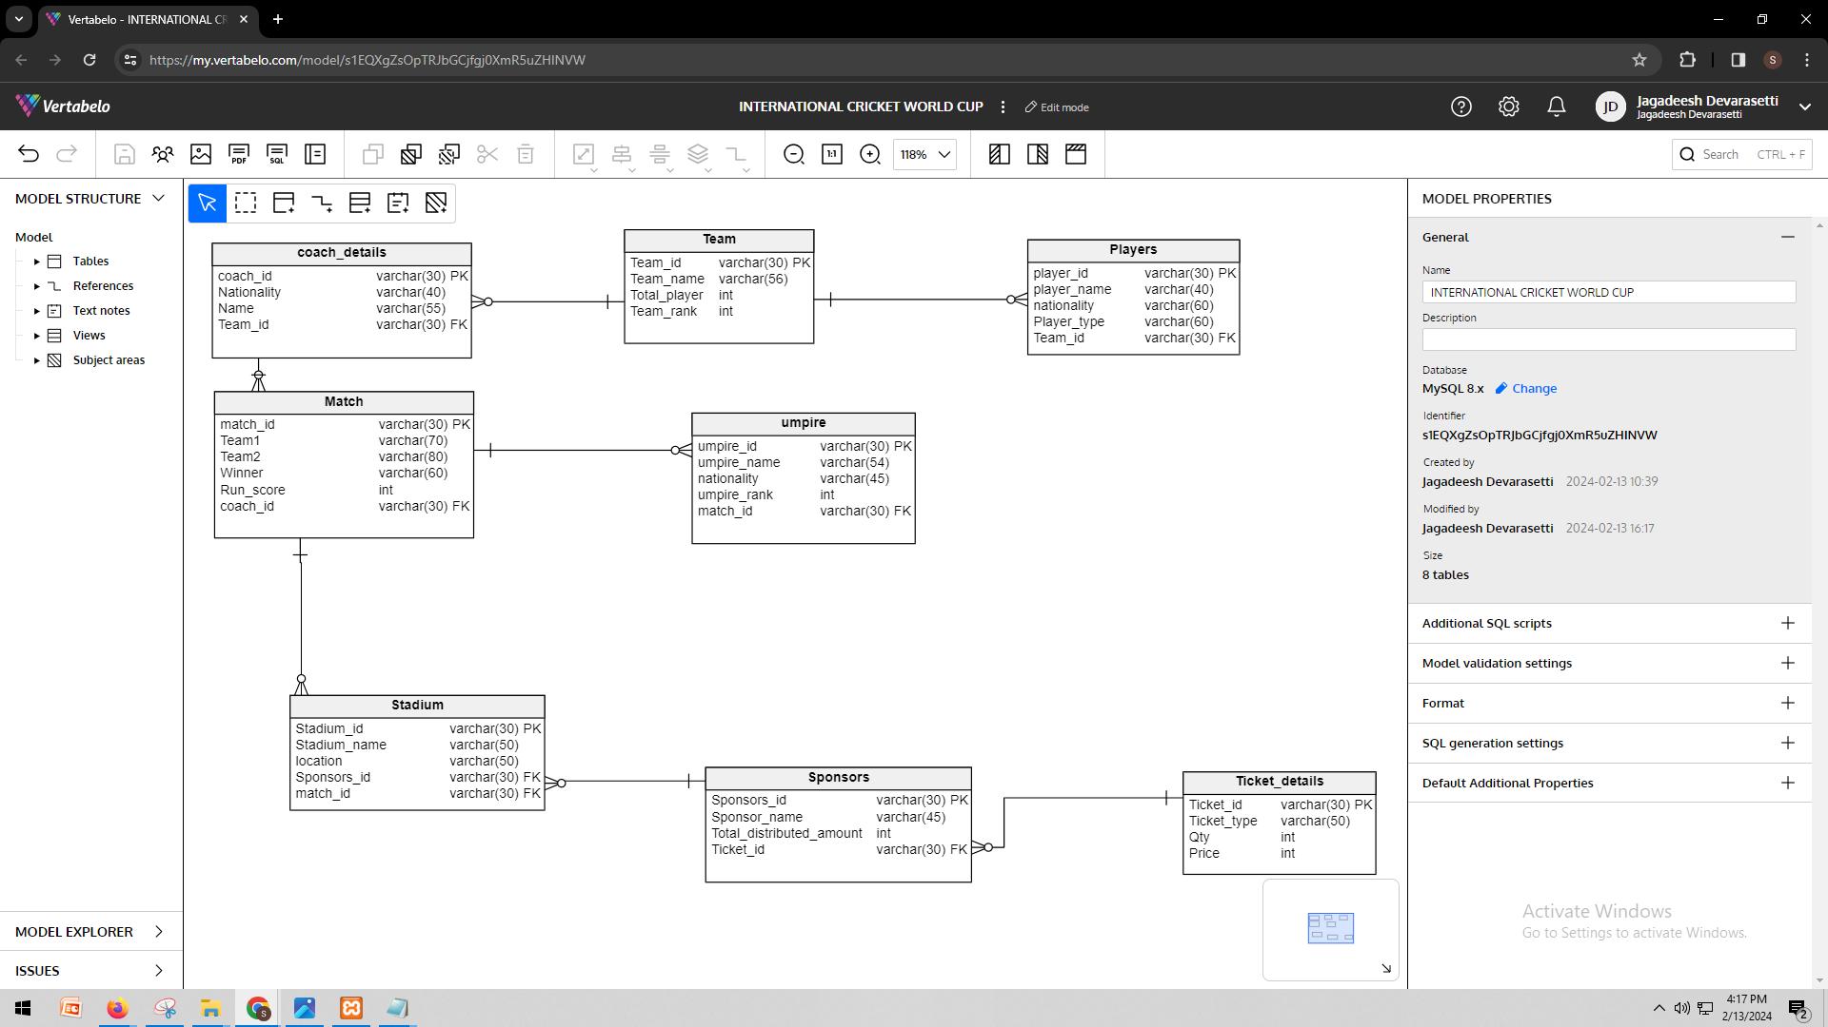

**G. Populate the database with data: similar to how I explained to you how I took a data set of music data and used it to populate my database, here I need you to clearly explain how you are transforming your data into commands for inserting data into your database. After the explanation, include screenshots (or a link to your github) that shows all the insert statements organized in SQL files. Then show screenshots of the data stored in your database after you run the insert statements. Use "select * from " along with each table name to show the data in each table.**

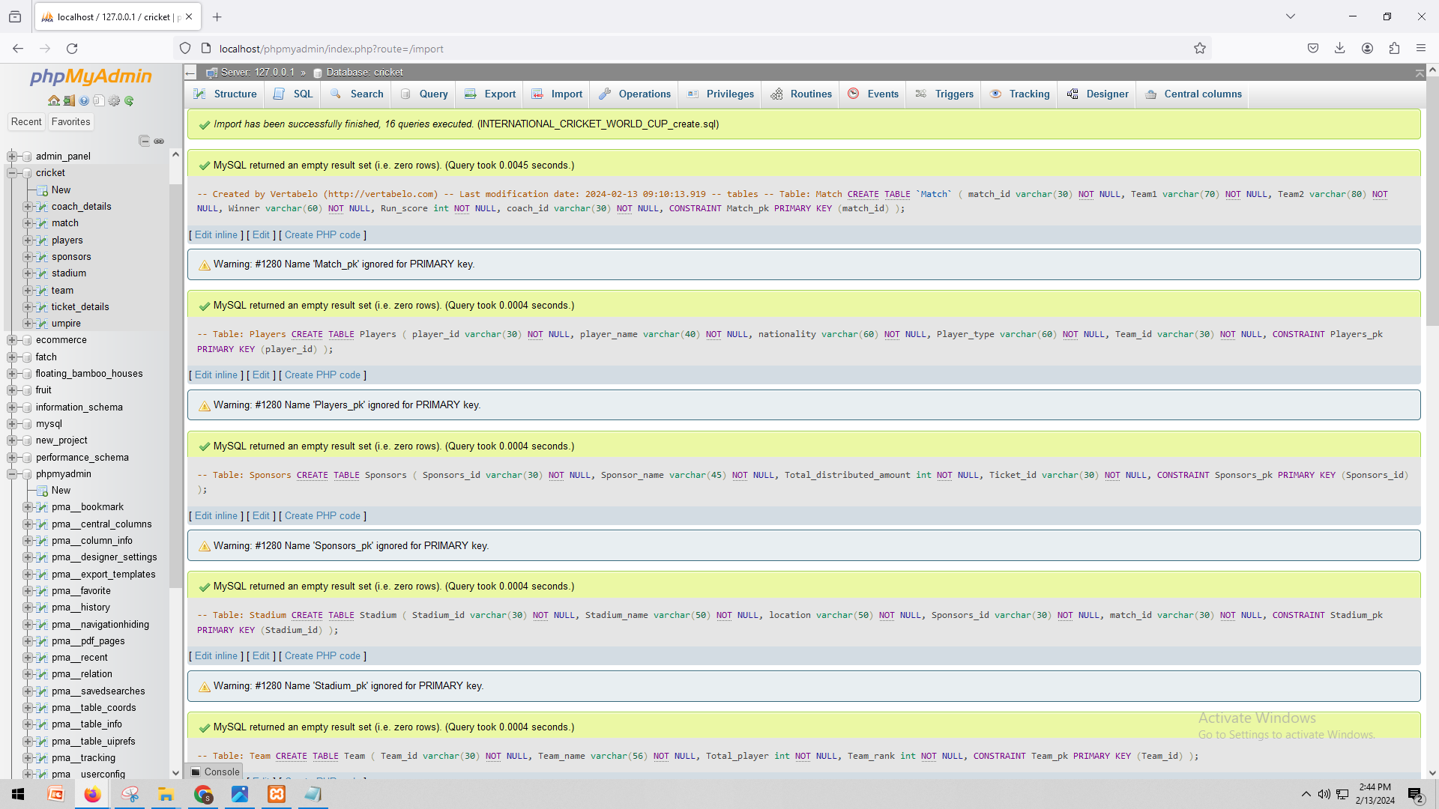

INSERT INTO `team`(`Team_id`, `Team_name`, `Total_player`, `Team_rank`) VALUES ('t1','Australia','14','1');

INSERT INTO `team`(`Team_id`, `Team_name`, `Total_player`, `Team_rank`) VALUES ('t2','New Zealand','13','4');

INSERT INTO `team`(`Team_id`, `Team_name`, `Total_player`, `Team_rank`) VALUES ('t3','South Africa','11','3');

INSERT INTO `team`(`Team_id`, `Team_name`, `Total_player`, `Team_rank`) VALUES ('t4','india','14','2')

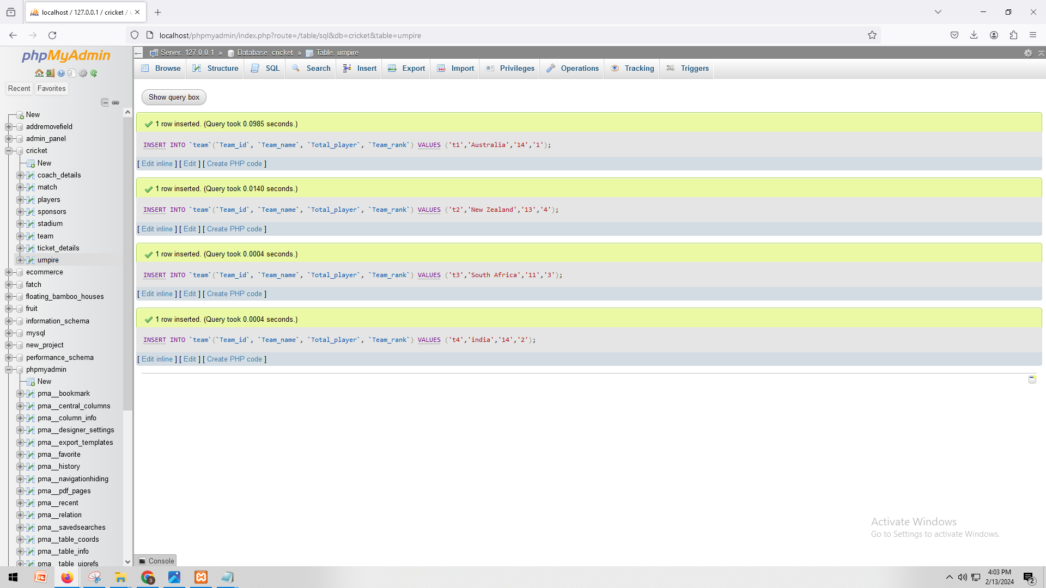

INSERT INTO `coach_details`(`coach_id`, `Nationality`, `Name`, `Team_id`) VALUES ('c1','Australia','Brad Hodge','t1');

INSERT INTO `coach_details`(`coach_id`, `Nationality`, `Name`, `Team_id`) VALUES ('c2','New Zealand','Stephen Fleming','t2');

INSERT INTO `coach_details`(`coach_id`, `Nationality`, `Name`, `Team_id`) VALUES ('c3','South Africa','Gary Kirstern','t3');

INSERT INTO `coach_details`(`coach_id`, `Nationality`, `Name`, `Team_id`) VALUES ('c4','india','Rajeev Kumar','t4')

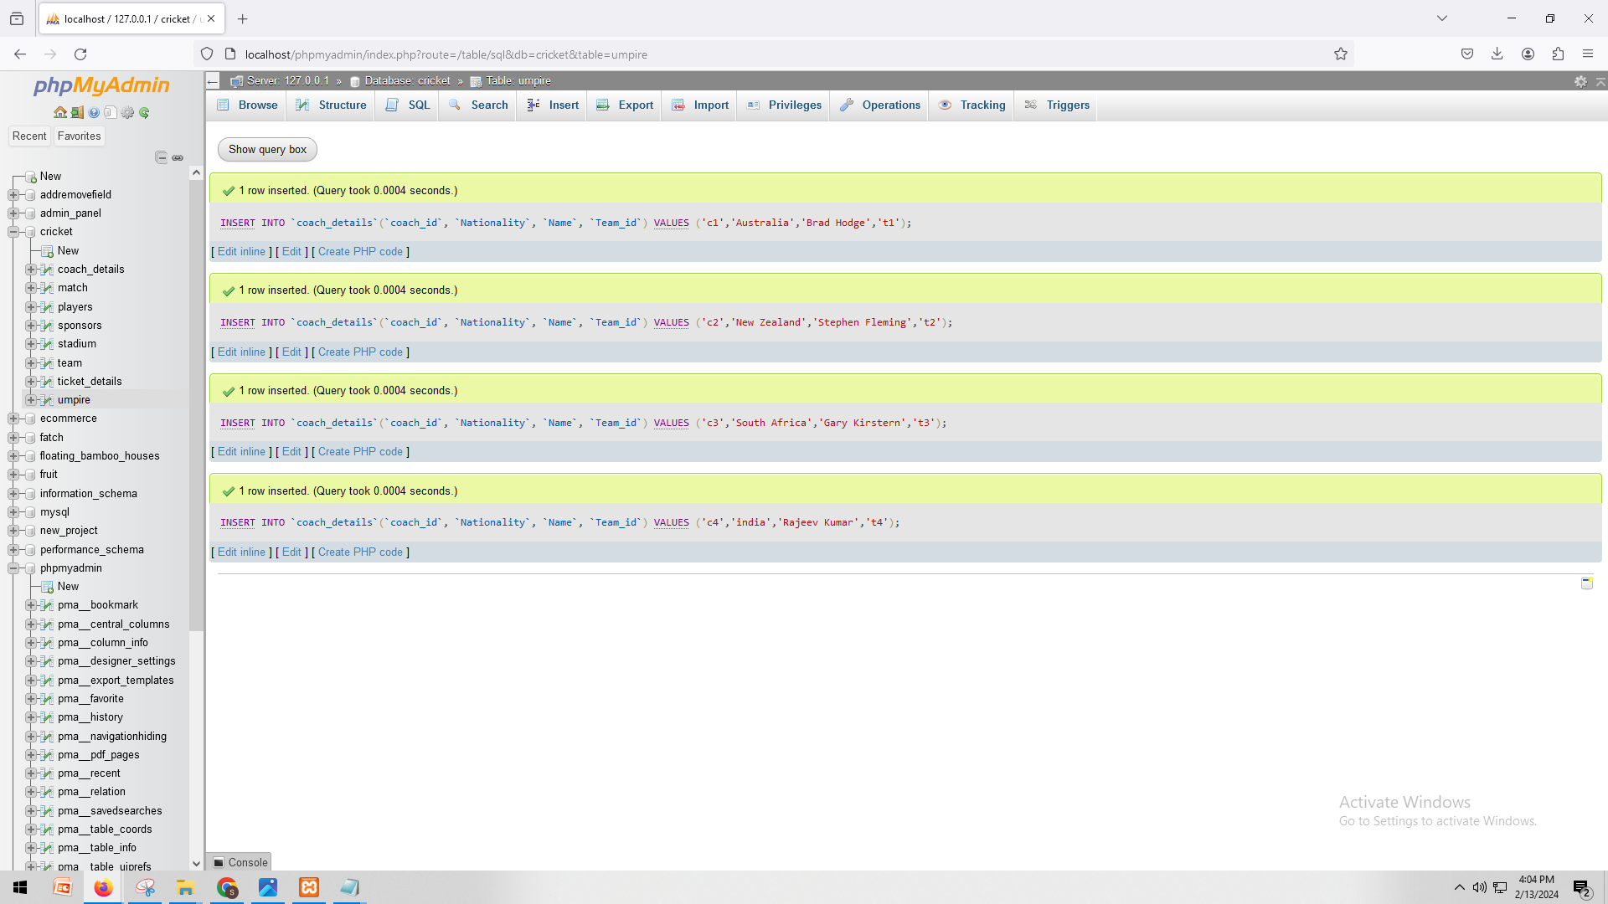

INSERT INTO `match`(`match_id`, `Team1`, `Team2`, `Winner`, `Run_score`, `coach_id`) VALUES ('m1','Australia','India','Australia','300','c1');

INSERT INTO `match`(`match_id`, `Team1`, `Team2`, `Winner`, `Run_score`, `coach_id`) VALUES ('m2','New Zealand','Australia','New Zealand','300','c2');

INSERT INTO `match`(`match_id`, `Team1`, `Team2`, `Winner`, `Run_score`, `coach_id`) VALUES ('m3','South Africa','India','India','300','c3');

INSERT INTO `match`(`match_id`, `Team1`, `Team2`, `Winner`, `Run_score`, `coach_id`) VALUES ('m4','Australia','India','Australia','300','c4')

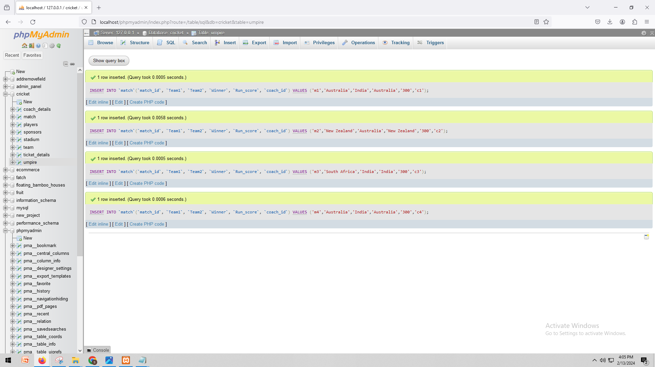

INSERT INTO `ticket_details`(`Ticket_id`, `Ticket_type`, `Qty`, `Price`) VALUES ('tid1','1st floor','2','4500');

INSERT INTO `ticket_details`(`Ticket_id`, `Ticket_type`, `Qty`, `Price`) VALUES ('tid2','3rd floor','2','545454');

INSERT INTO `ticket_details`(`Ticket_id`, `Ticket_type`, `Qty`, `Price`) VALUES ('tid3','1st floor','2','6789');

INSERT INTO `ticket_details`(`Ticket_id`, `Ticket_type`, `Qty`, `Price`) VALUES ('tid4','VIP','2','76760')

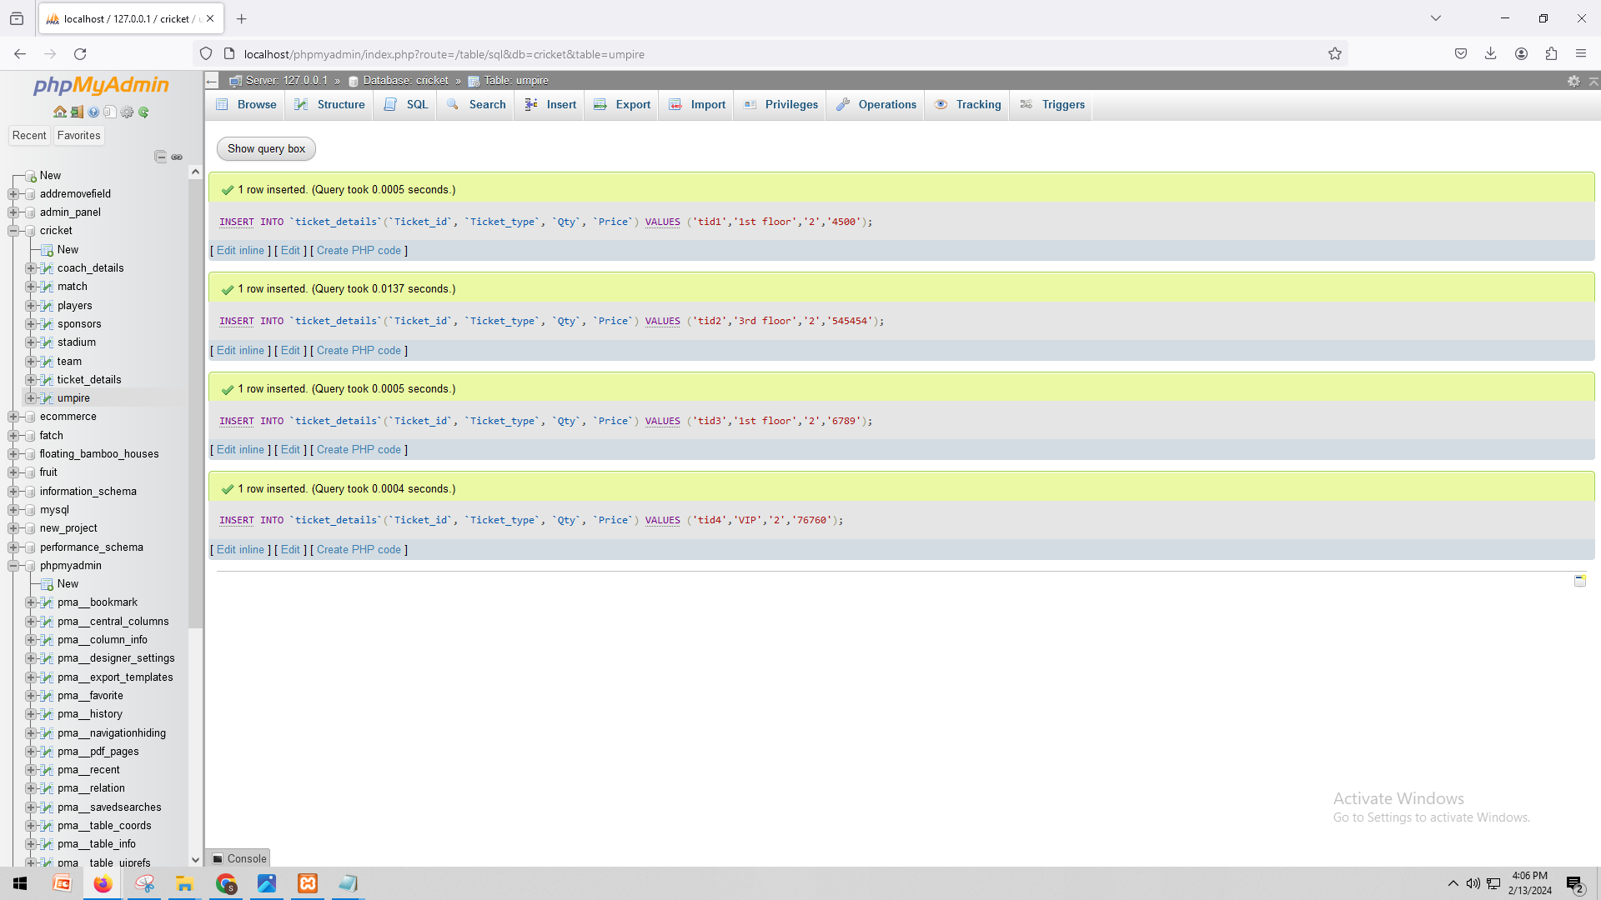

INSERT INTO `sponsors`(`Sponsors_id`, `Sponsor_name`, `Total_distributed_amount`, `Ticket_id`) VALUES ('s1','Emirates','19090','tid1');

INSERT INTO `sponsors`(`Sponsors_id`, `Sponsor_name`, `Total_distributed_amount`, `Ticket_id`) VALUES ('s2','Dream11','23424','tid2');

INSERT INTO `sponsors`(`Sponsors_id`, `Sponsor_name`, `Total_distributed_amount`, `Ticket_id`) VALUES ('s3','Nissan','4565546','tid3');

INSERT INTO `sponsors`(`Sponsors_id`, `Sponsor_name`, `Total_distributed_amount`, `Ticket_id`) VALUES ('s4','Nium','675777','tid4');

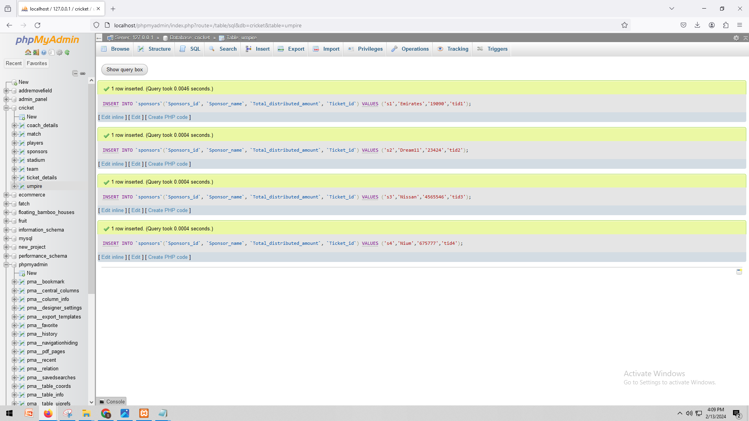

INSERT INTO `players`(`player_id`, `player_name`, `nationality`, `Player_type`, `Team_id`) VALUES ('p1','Harbhajan','indian','bowler','t1');

INSERT INTO `players`(`player_id`, `player_name`, `nationality`, `Player_type`, `Team_id`) VALUES ('p2','Pollard','West Indies','All Rounder','t2');

INSERT INTO `players`(`player_id`, `player_name`, `nationality`, `Player_type`, `Team_id`) VALUES ('p3','Plessis','South Africa','batsman','t3');

INSERT INTO `players`(`player_id`, `player_name`, `nationality`, `Player_type`, `Team_id`) VALUES ('p4','Buttler','England','Wk','t4');

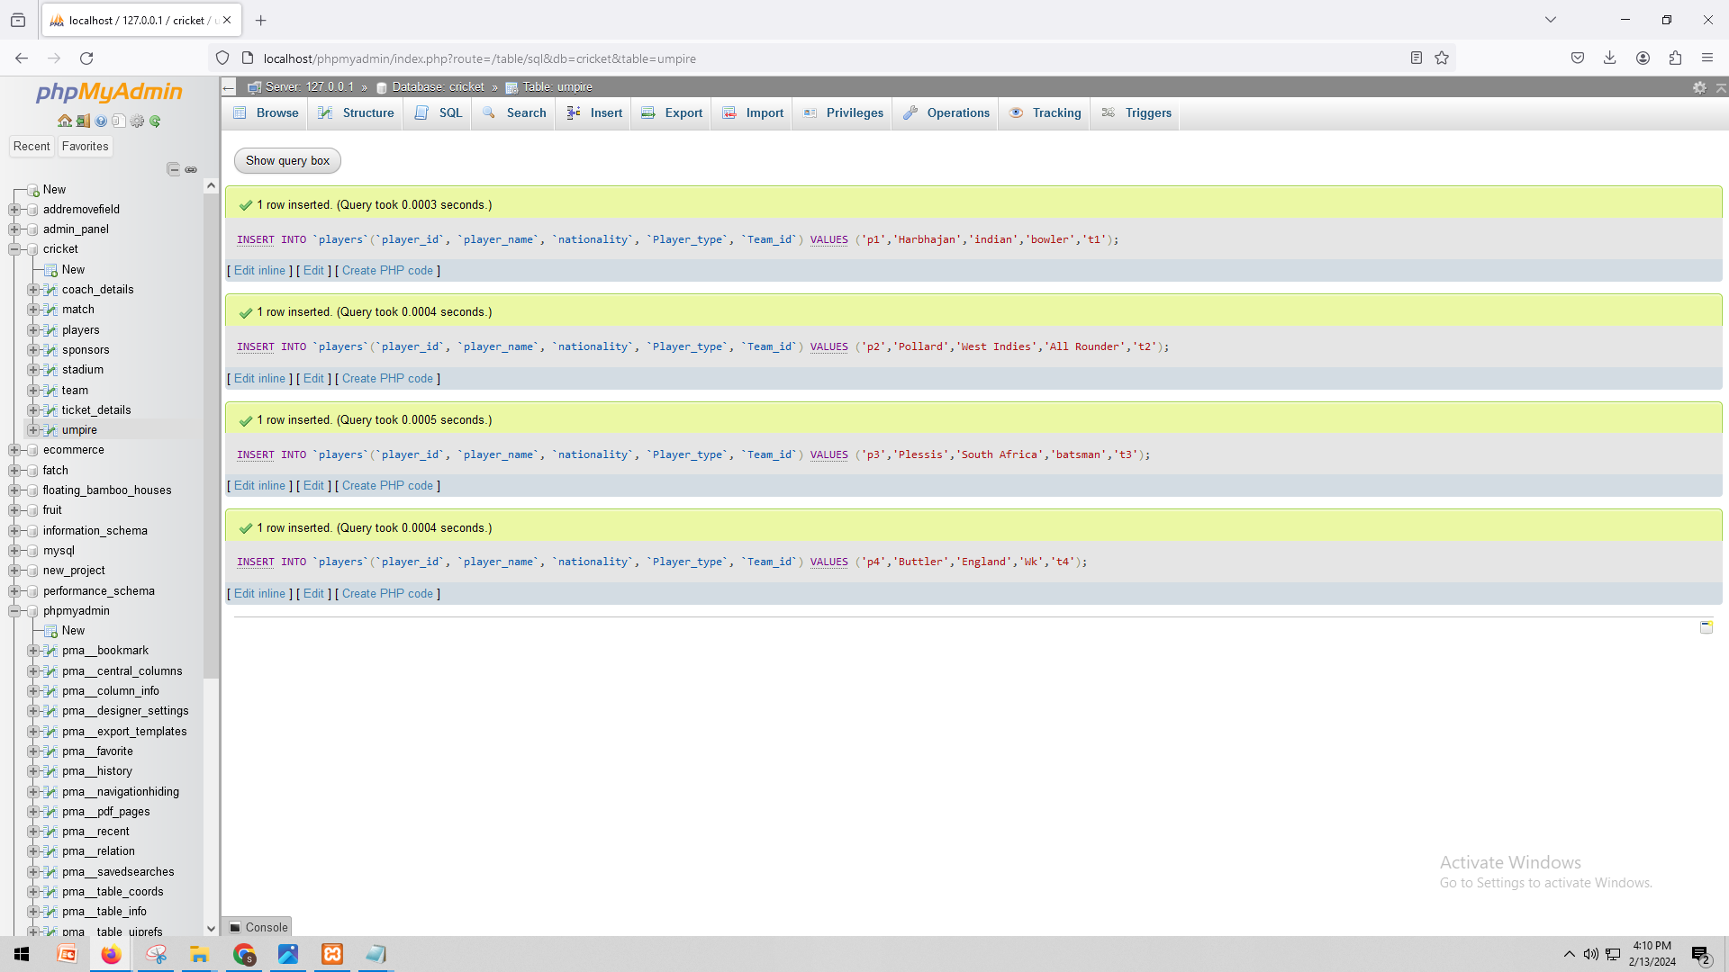

INSERT INTO `stadium`(`Stadium_id`, `Stadium_name`, `location`, `Sponsors_id`, `match_id`) VALUES ('sta1','MCA Stadium','Pune','s1','m1');

INSERT INTO `stadium`(`Stadium_id`, `Stadium_name`, `location`, `Sponsors_id`, `match_id`) VALUES ('sta2','M. C.Stadium','England','s2','m2');

INSERT INTO `stadium`(`Stadium_id`, `Stadium_name`, `location`, `Sponsors_id`, `match_id`) VALUES ('sta3','PCA Stadium','Australia','s3','m3');

INSERT INTO `stadium`(`Stadium_id`, `Stadium_name`, `location`, `Sponsors_id`, `match_id`) VALUES ('sta4','W Stadium','South Africa','s4','m4');

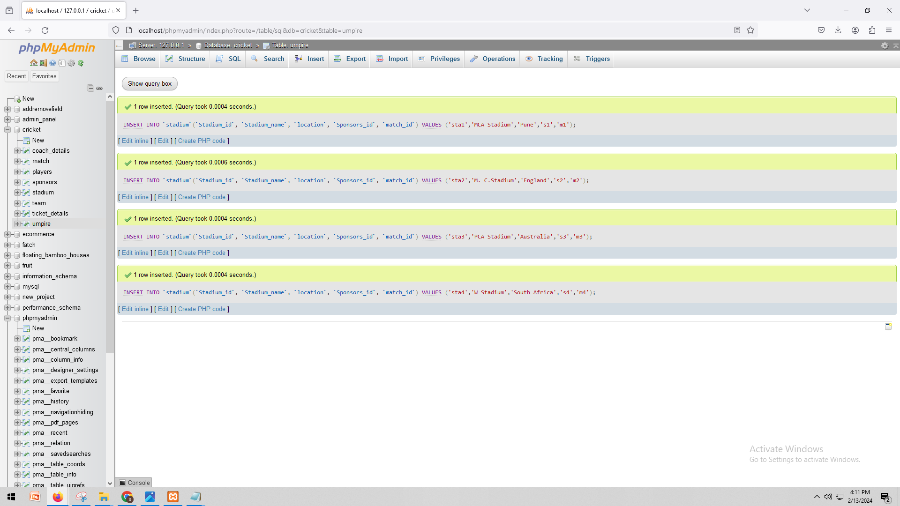

INSERT INTO `umpire`(`umpire_id`, `umpire_name`, `nationality`, `umpire_rank`, `match_id`) VALUES ('u1','Asnani','India','3','m1');

INSERT INTO `umpire`(`umpire_id`, `umpire_name`, `nationality`, `umpire_rank`, `match_id`) VALUES ('u2','RKIllingworth','England','2','m2');

INSERT INTO `umpire`(`umpire_id`, `umpire_name`, `nationality`, `umpire_rank`, `match_id`) VALUES ('u3','NJ Llong','England','3','m3');

INSERT INTO `umpire`(`umpire_id`, `umpire_name`, `nationality`, `umpire_rank`, `match_id`) VALUES ('u4','SJ Davis','England','3','m4')

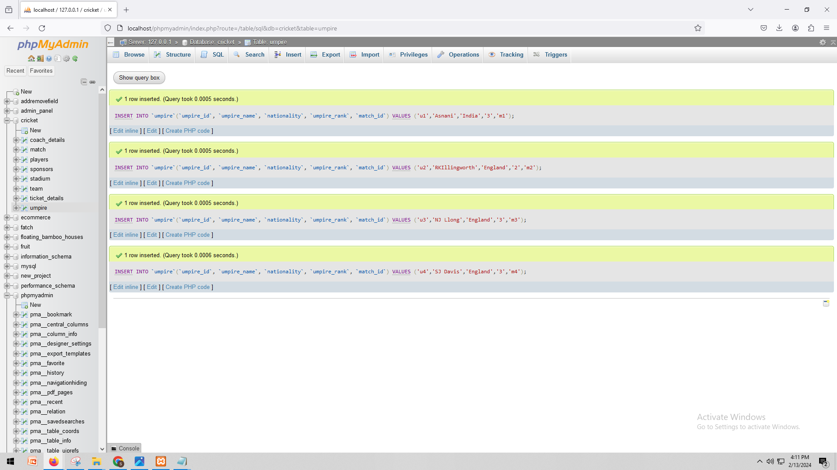

Show the data:

SELECT * FROM `coach_details`

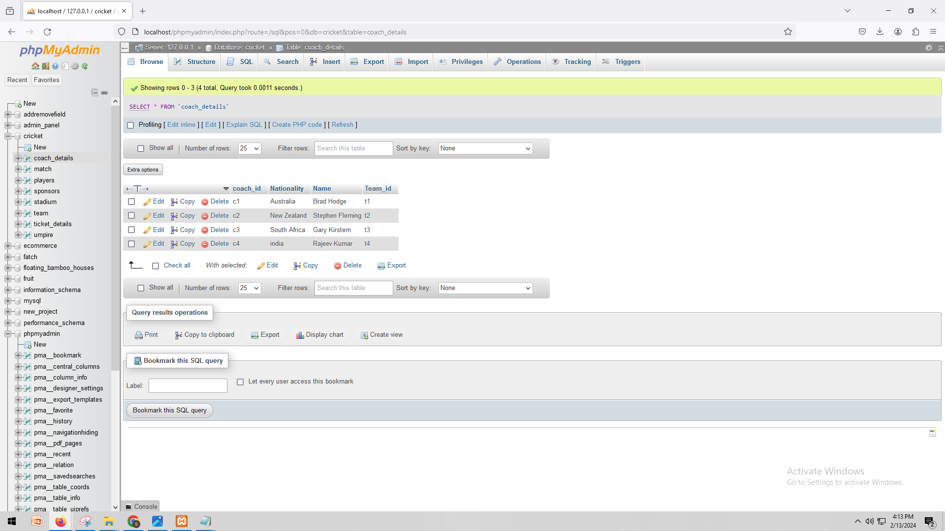

SELECT * FROM `match`

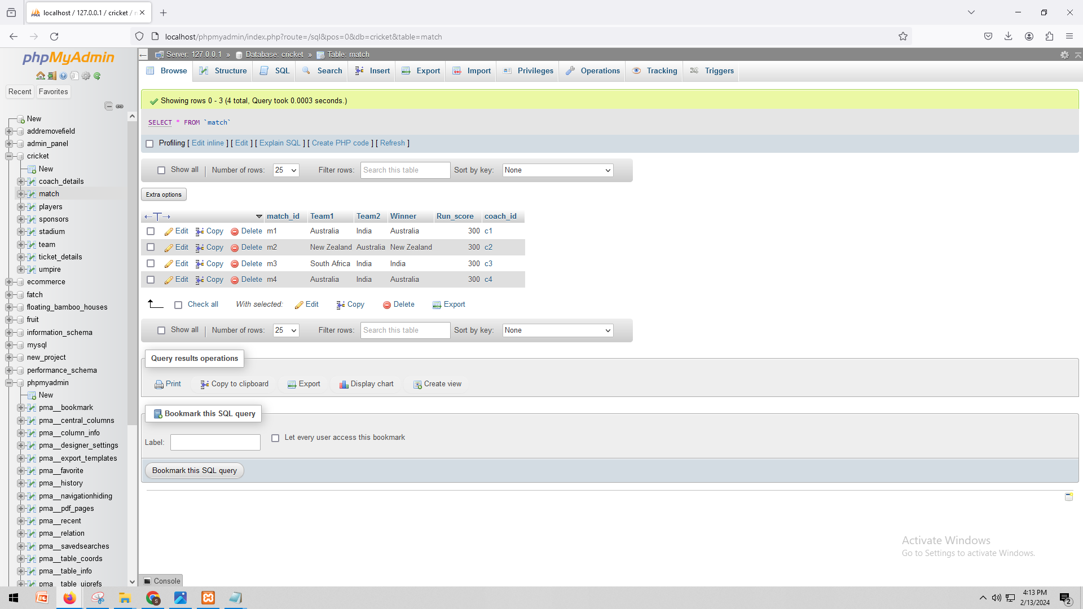

SELECT * FROM `players`

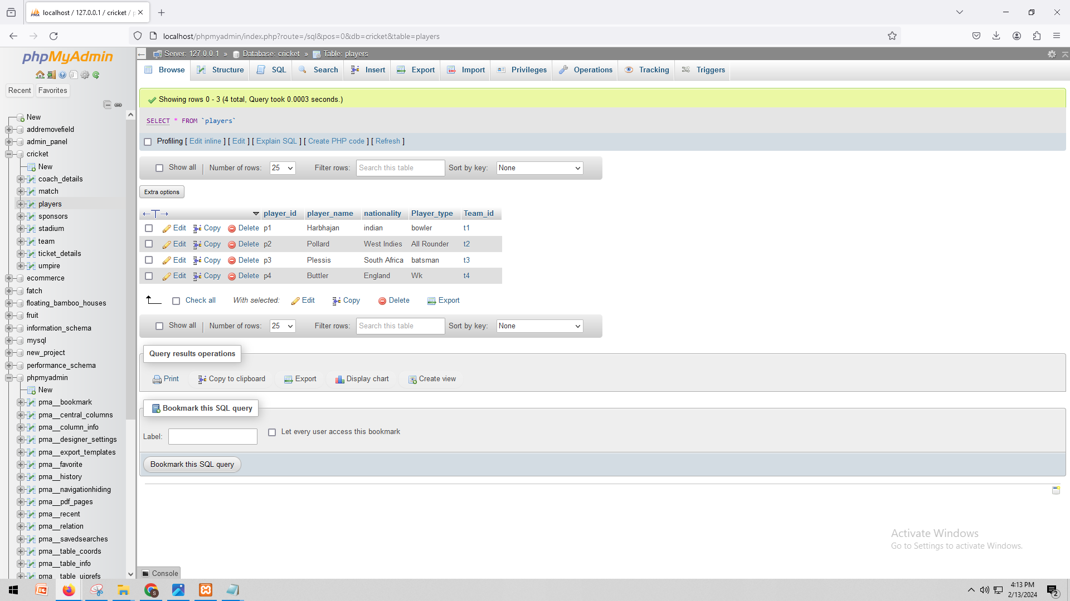

SELECT * FROM `sponsors`

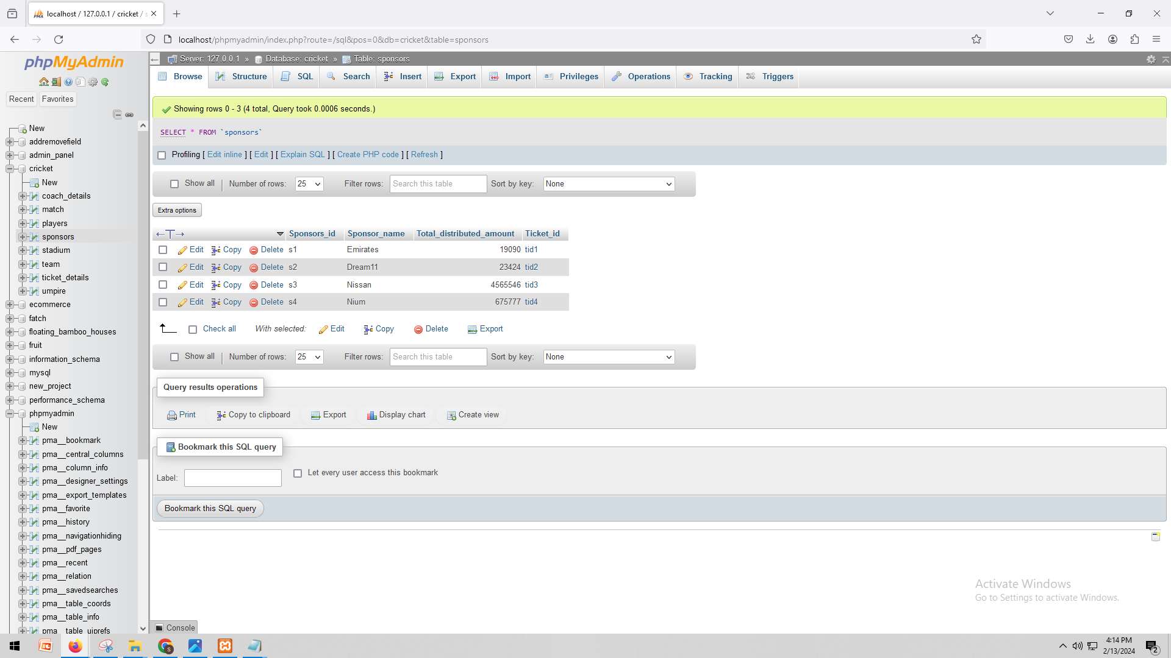

SELECT * FROM `stadium`

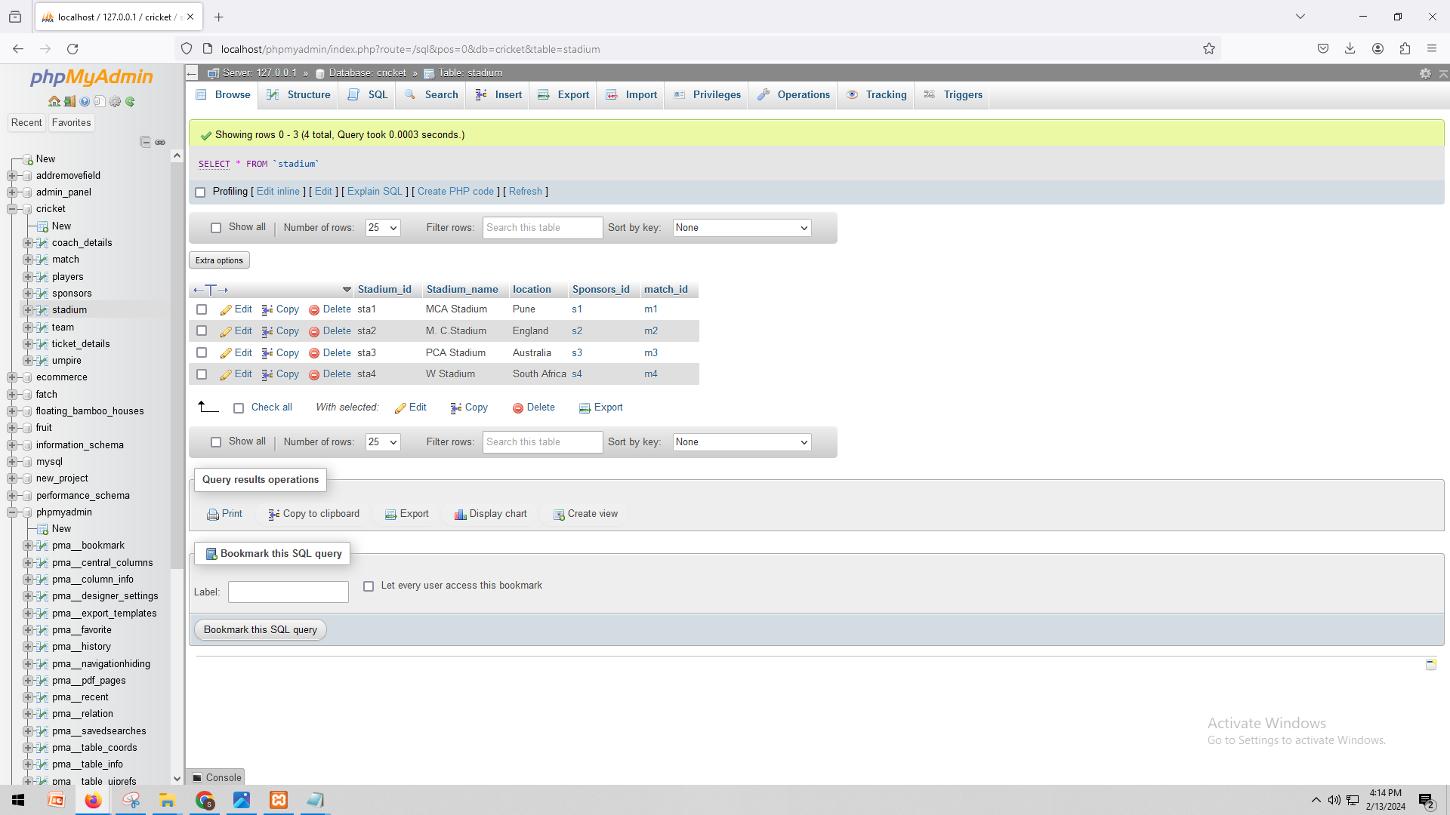

SELECT * FROM `team`

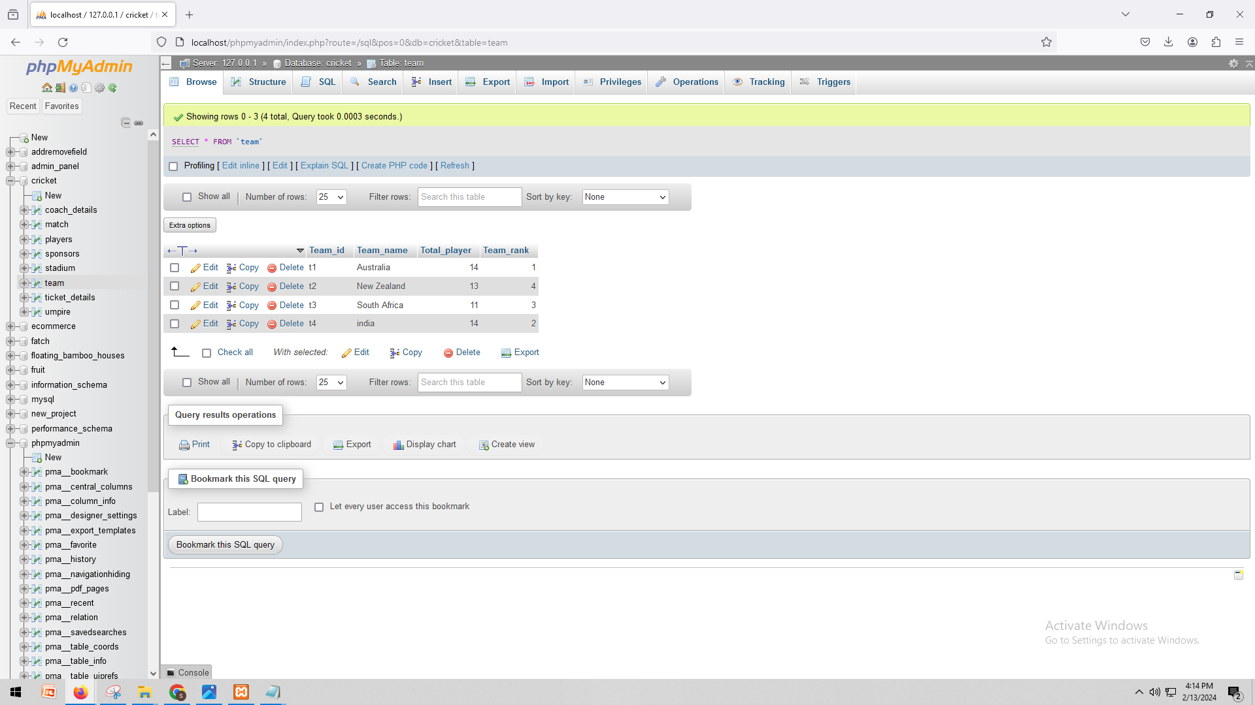

SELECT * FROM `ticket_details`

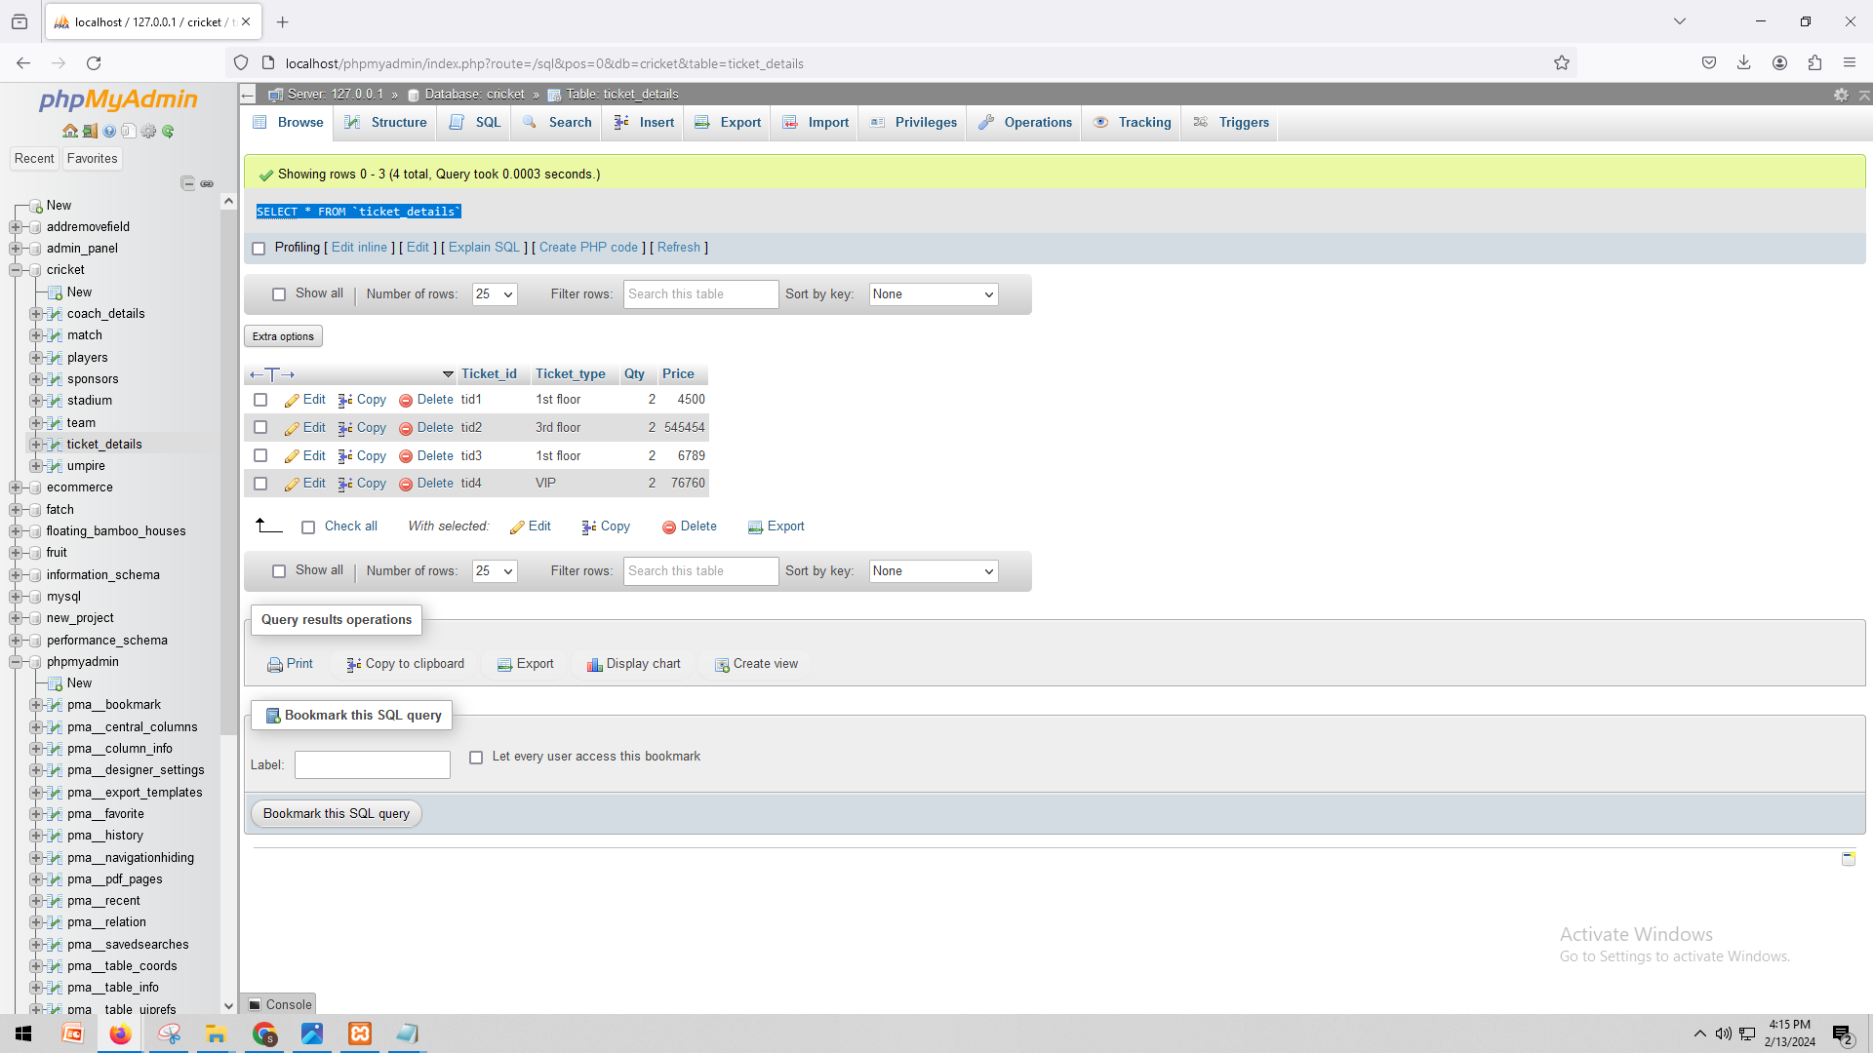

SELECT * FROM `umpire`

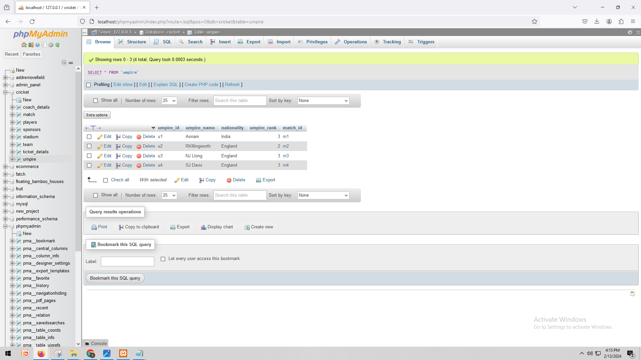

# H. Data Manipulation Language Scripts

INSERT INTO `team`(`Team_id`, `Team_name`, `Total_player`, `Team_rank`) VALUES ('t5','bengladesh','20','5');

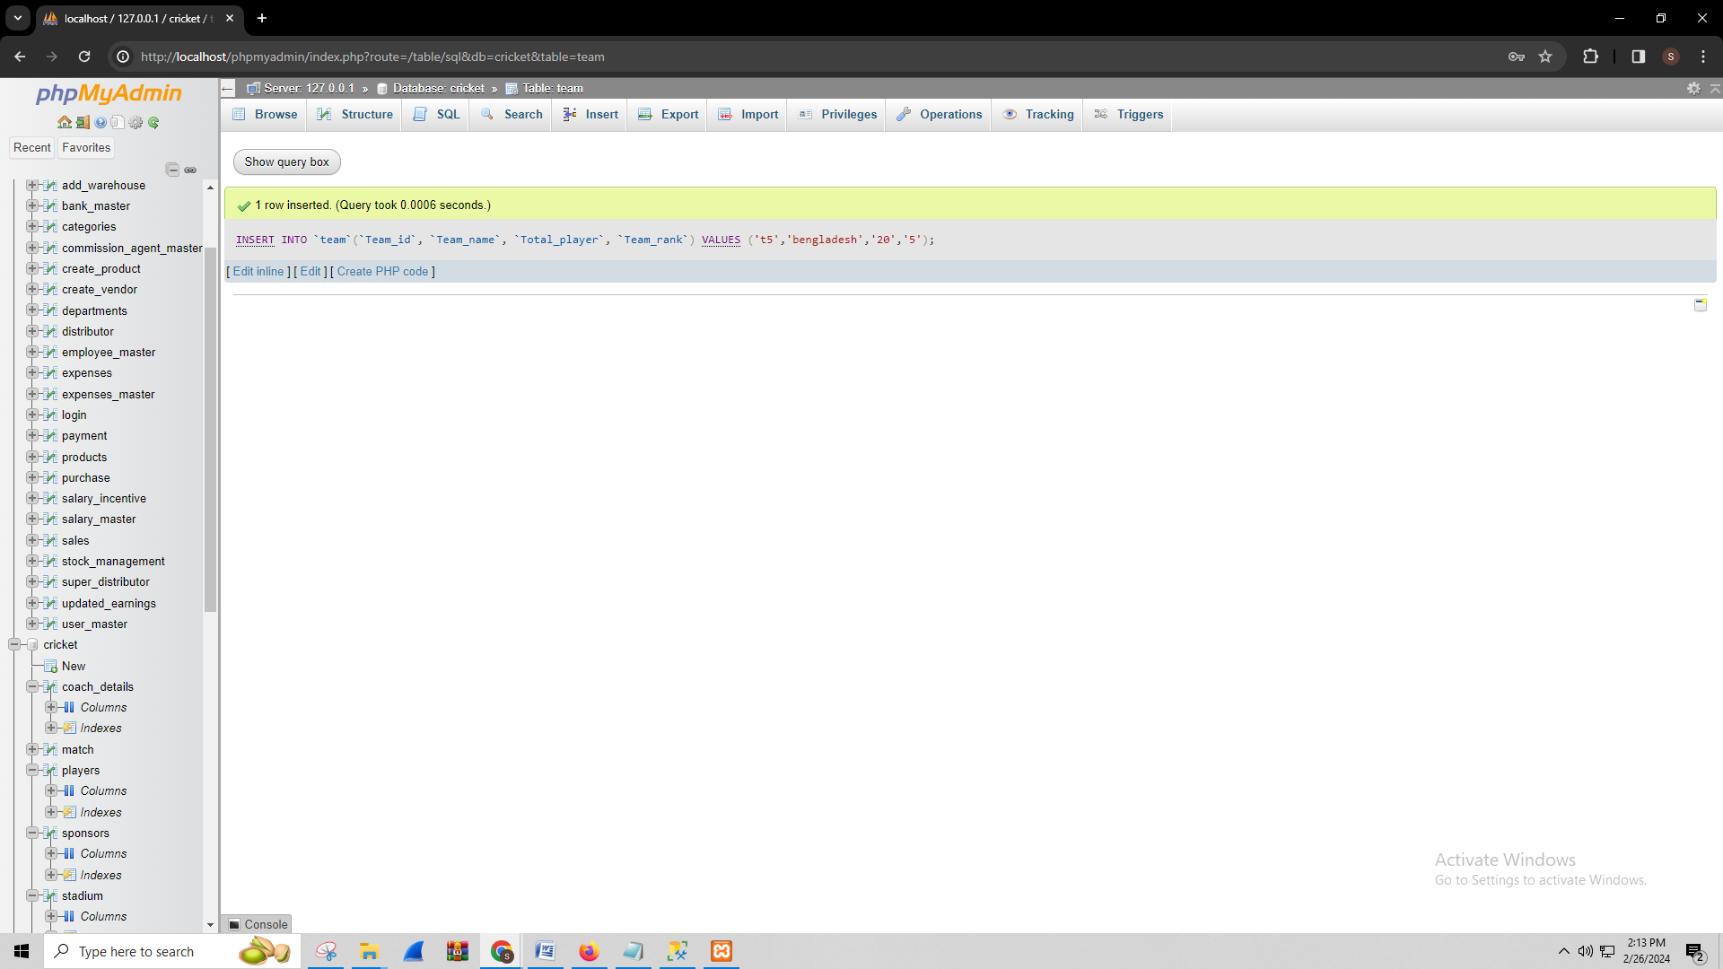

INSERT INTO `team`(`Team_id`, `Team_name`, `Total_player`, `Team_rank`) VALUES ('t6','sri-lanka','15','6');

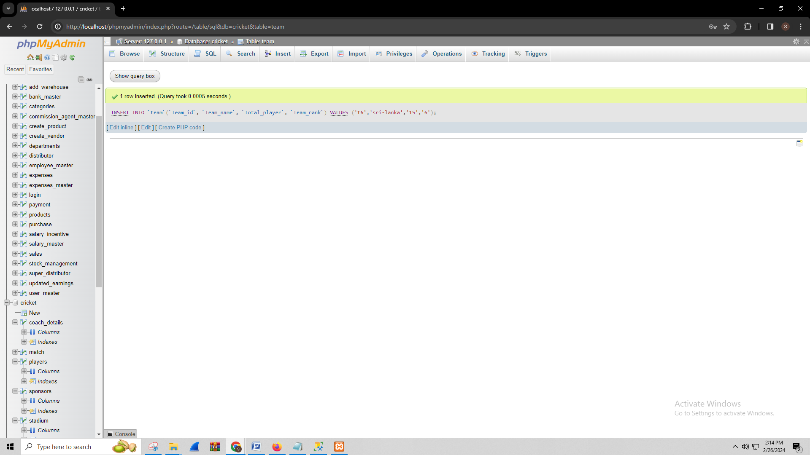

UPDATE `team` SET `Total_player`='24' WHERE `Team_id`='t6';

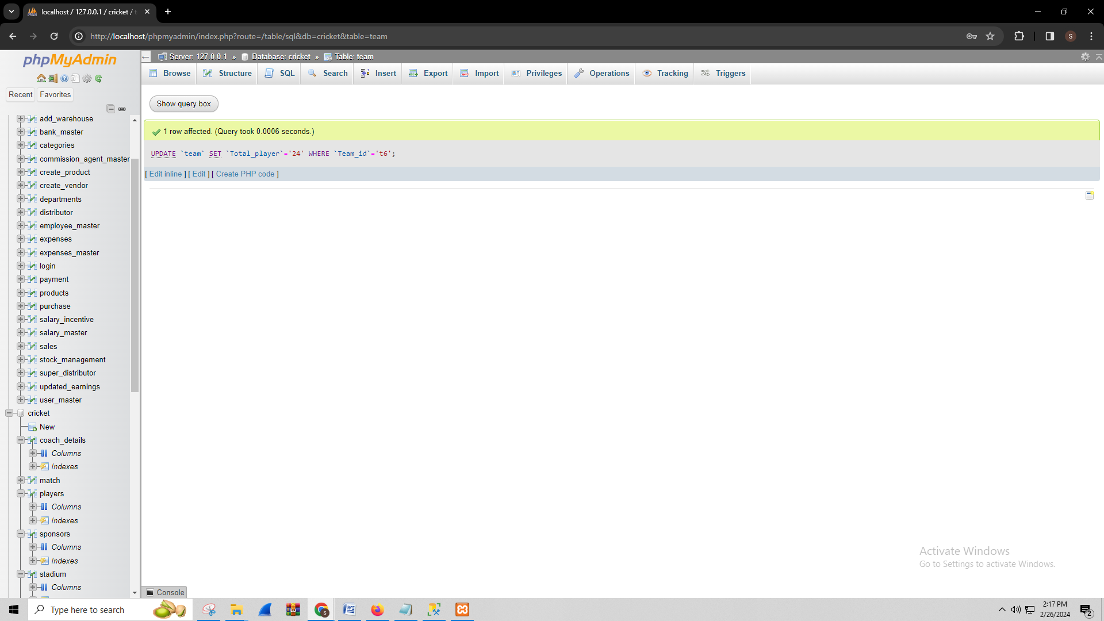

UPDATE `team` SET `Total_player`='23' WHERE `Team_id`='t5';

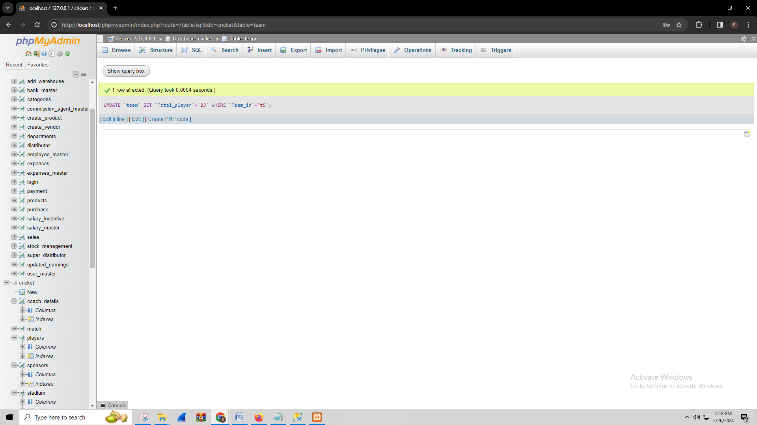

DELETE FROM `team` WHERE Team_id= 't5';

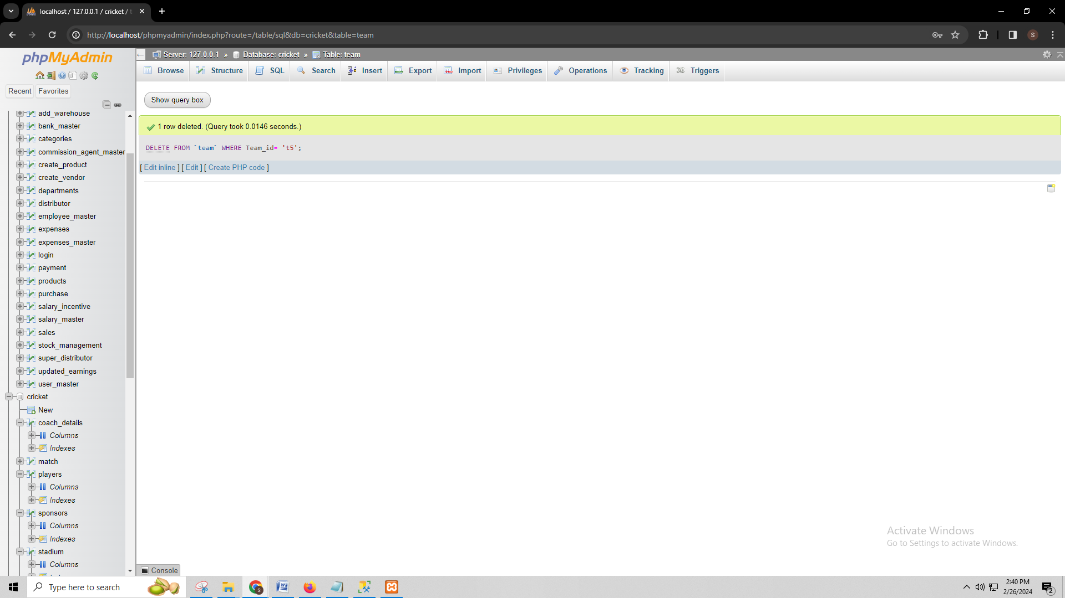

SELECT * FROM `team`;

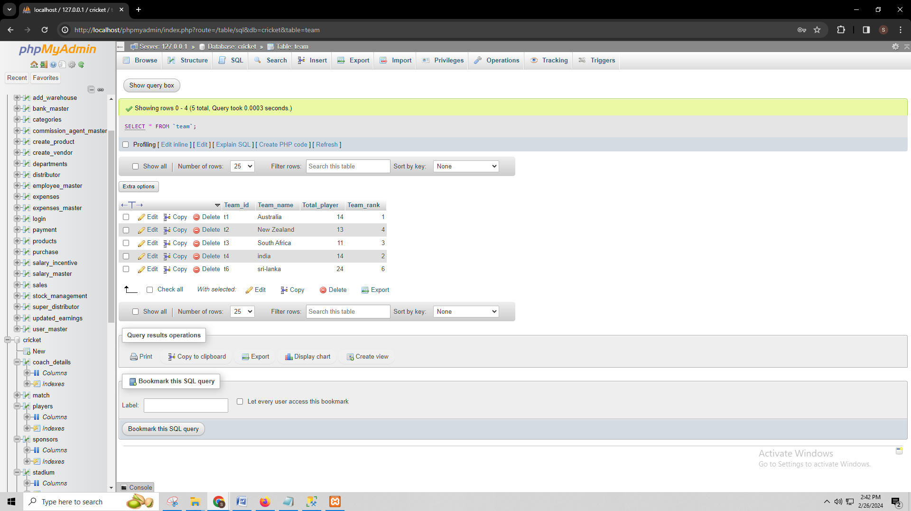

SELECT team.Team_id, players.player_name FROM team INNER JOIN players ON team.Team_id = players.Team_id;

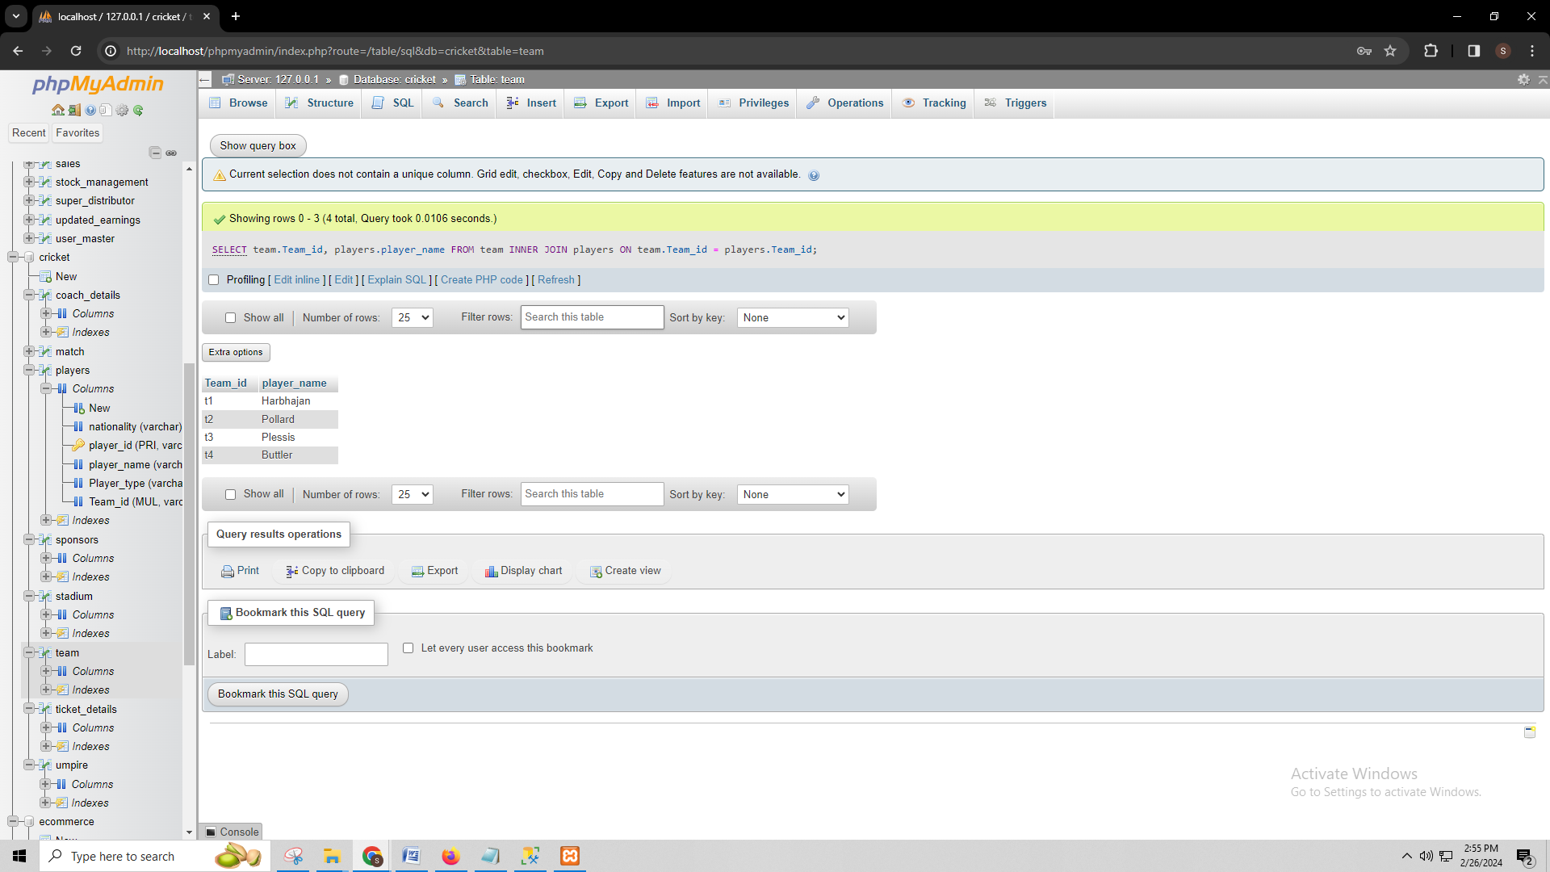

SELECT `match`.match_id, coach_details.coach_id FROM `match` LEFT JOIN coach_details ON `match`.match_id = coach_details.coach_id LIMIT 0, 25;

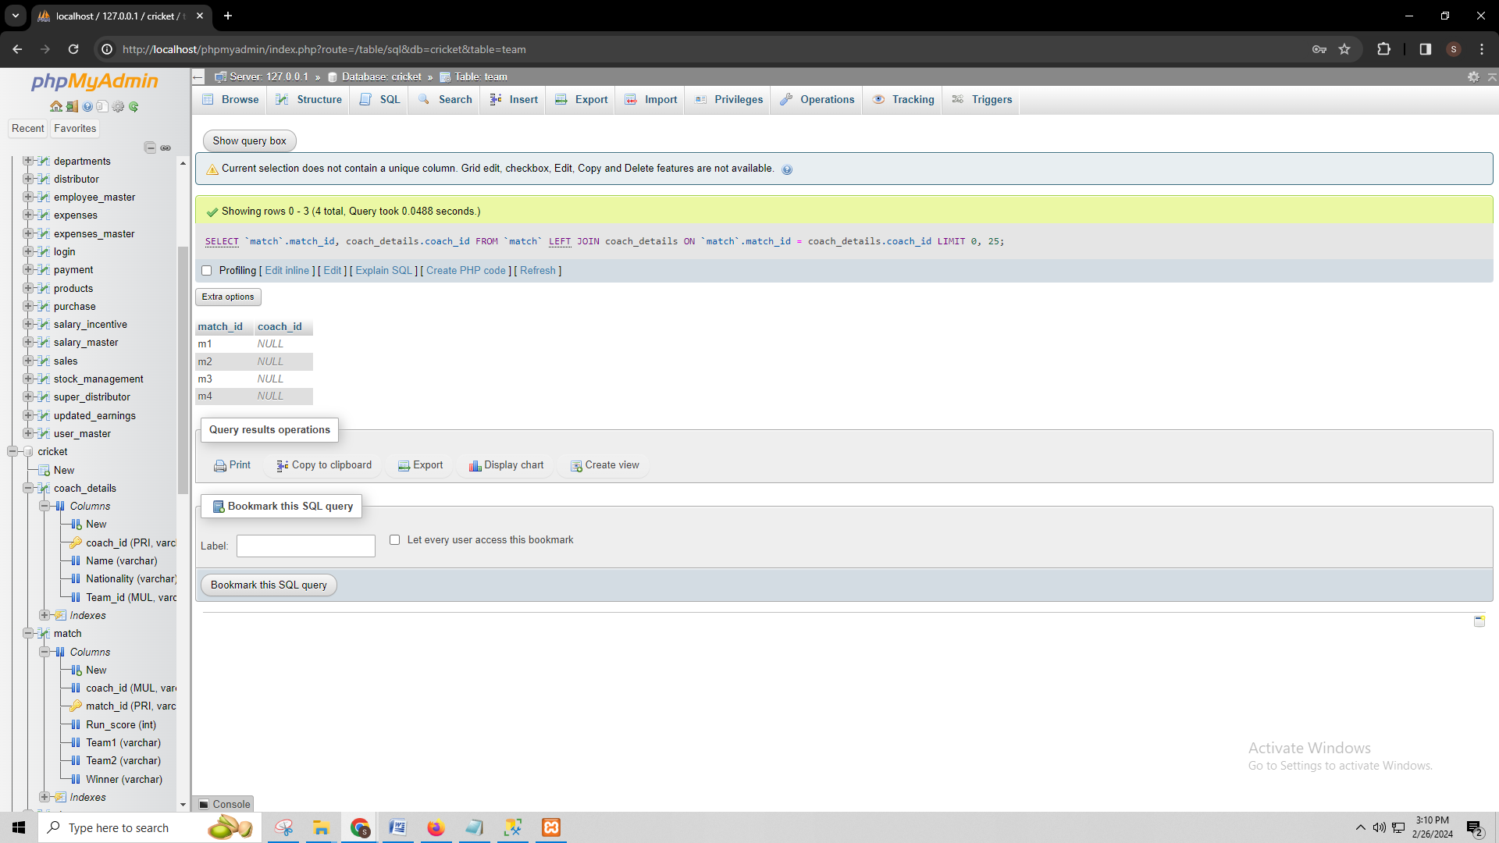

SELECT stadium.Stadium_id, sponsors.Sponsor_name, COUNT(sponsors.Sponsor_name) AS total_sponsors, SUM(sponsors.Total_distributed_amount) AS total_distributed_amount FROM stadium LEFT JOIN sponsors ON stadium.Stadium_id = sponsors.Sponsors_id GROUP BY stadium.Stadium_id, sponsors.Sponsor_name LIMIT 0, 25;

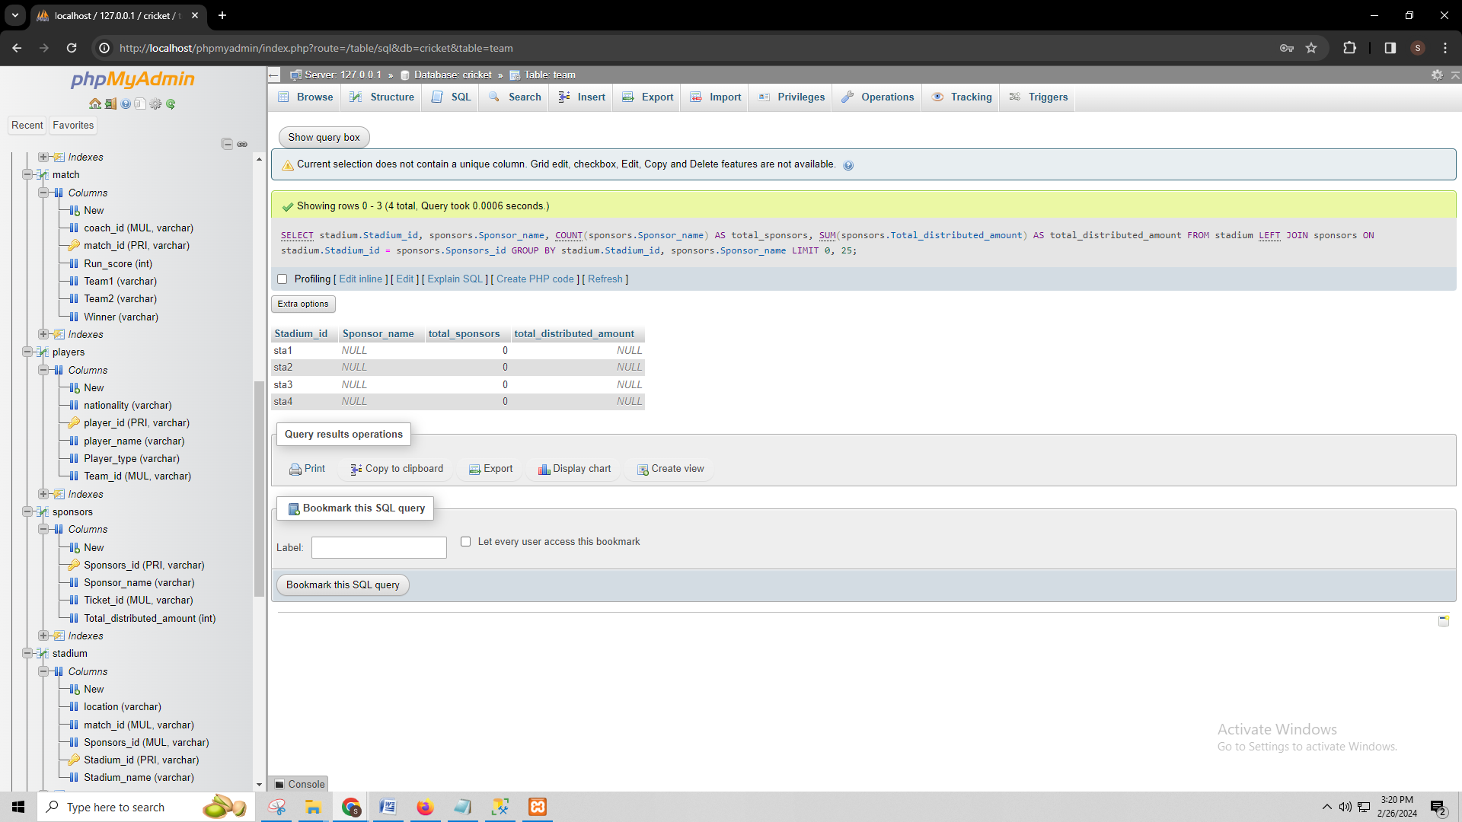

SELECT SUM( Qty * Price) FROM ticket_details;

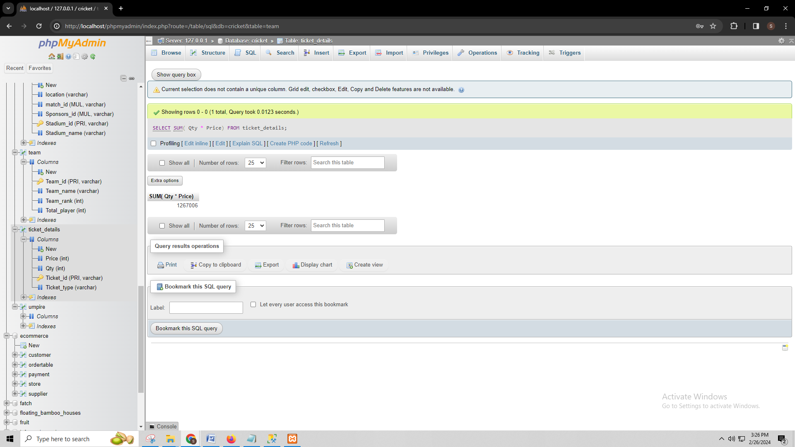

SELECT stadium.Stadium_id, sponsors.Sponsors_id,sponsors.Sponsor_name FROM stadium JOIN sponsors ON stadium.Stadium_id = sponsors.Sponsors_id;

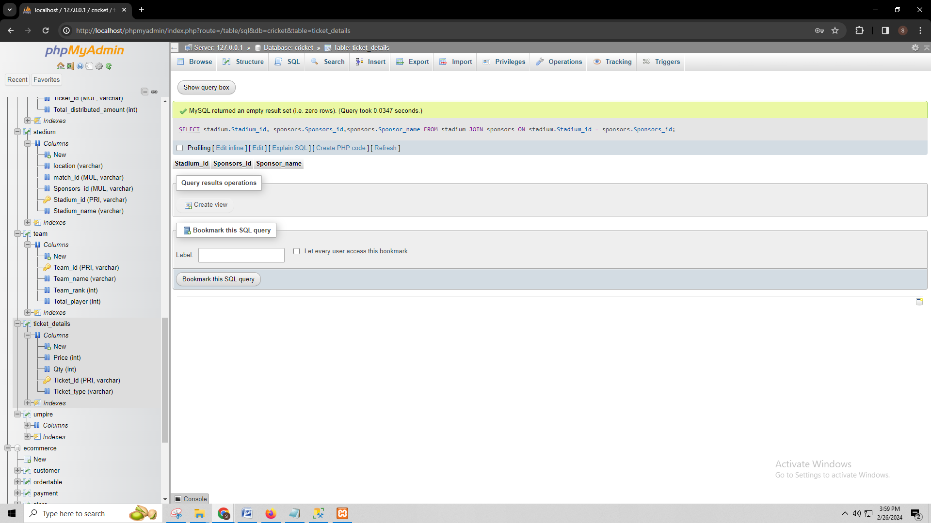

SELECT * FROM `coach_details`

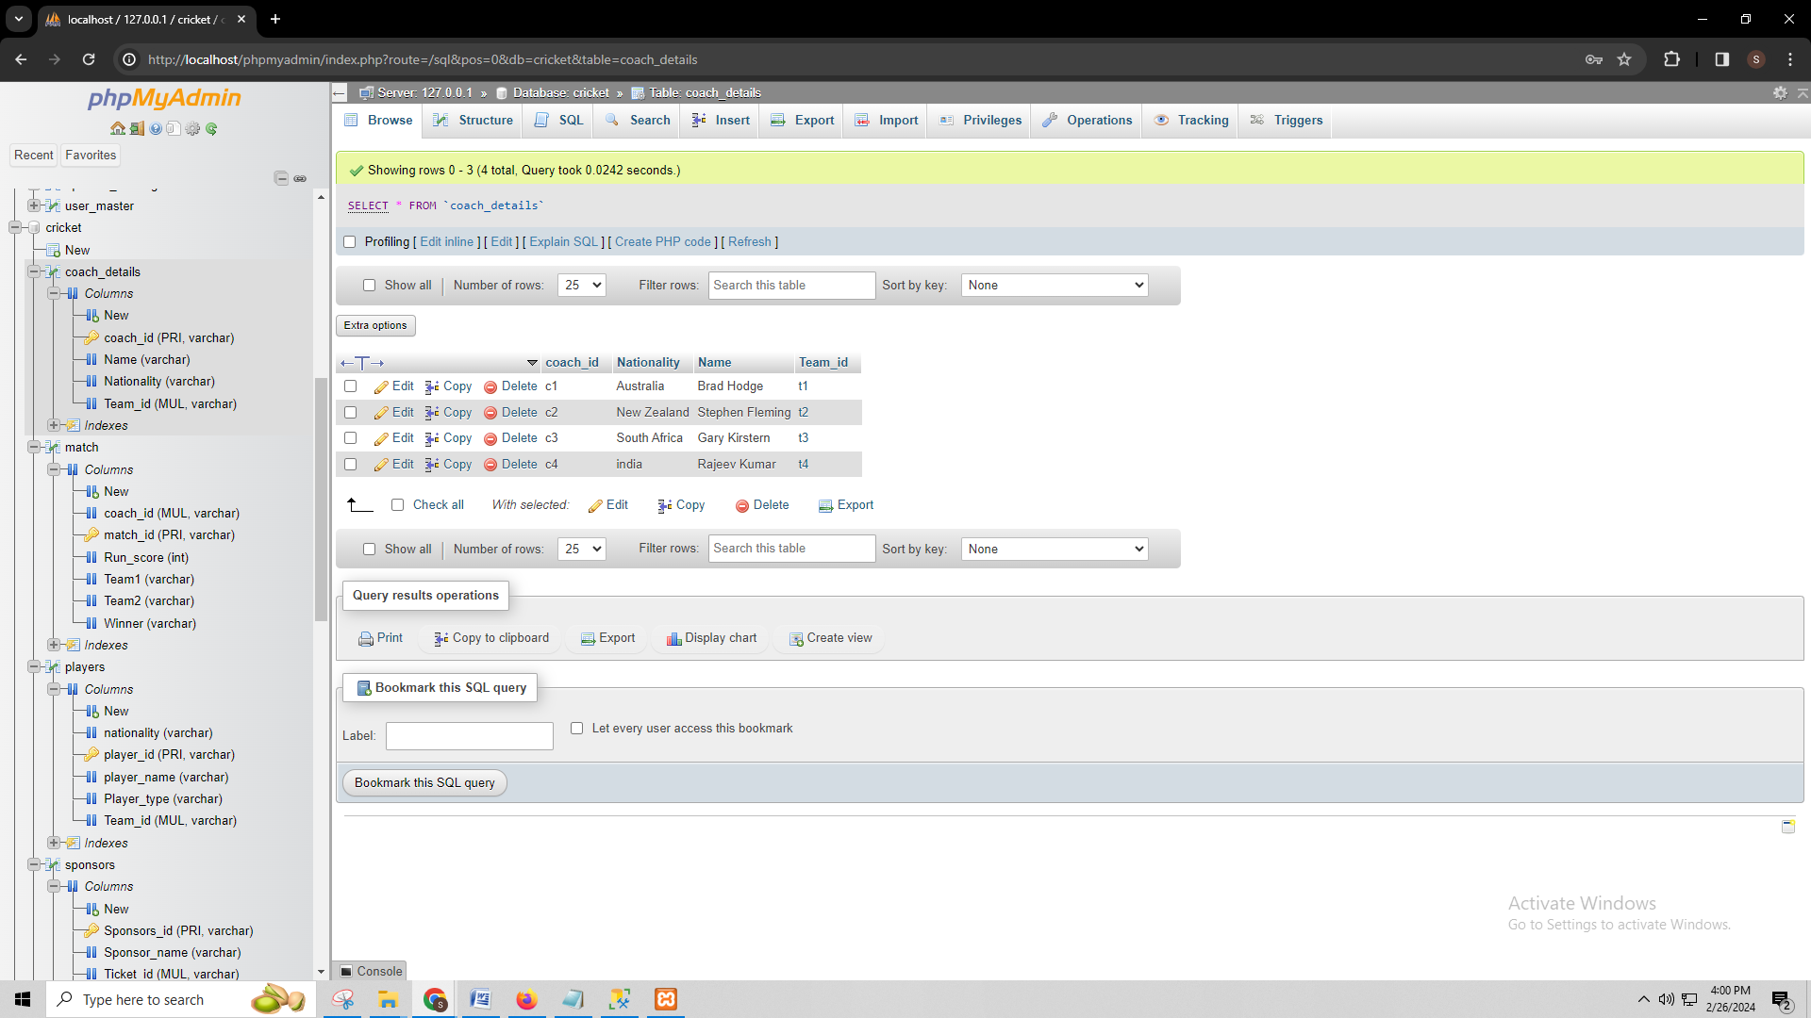

SELECT * FROM `players`

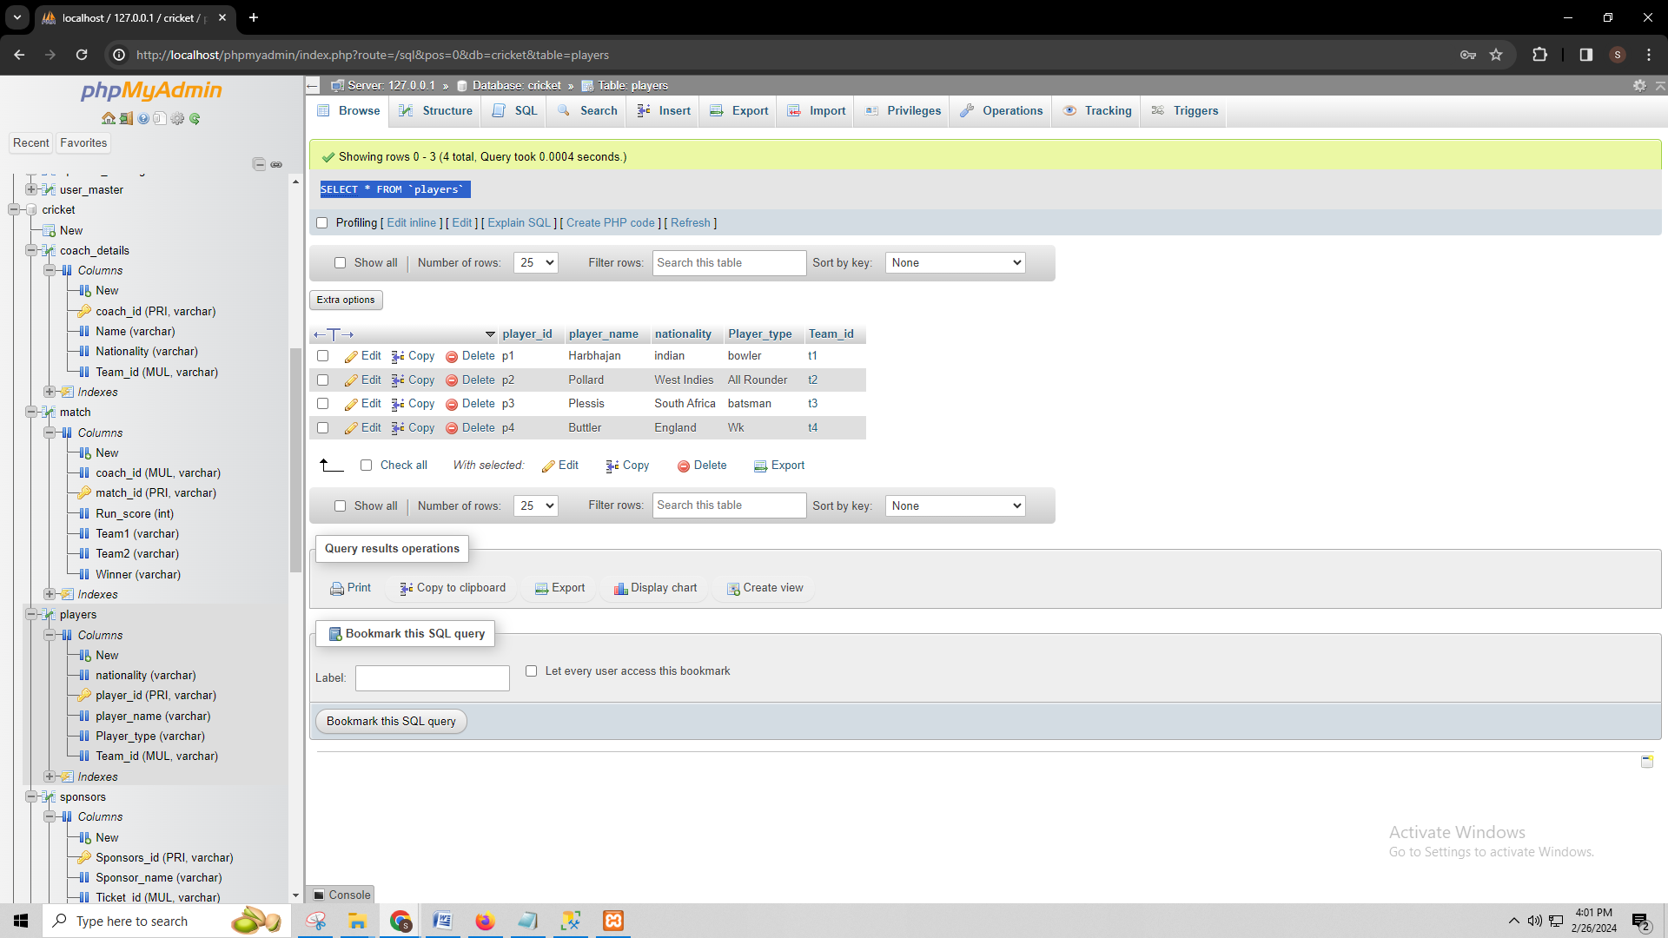

# I. Indexes

**CREATE INDEX coach_details ON coach_details(Name,nationality);**

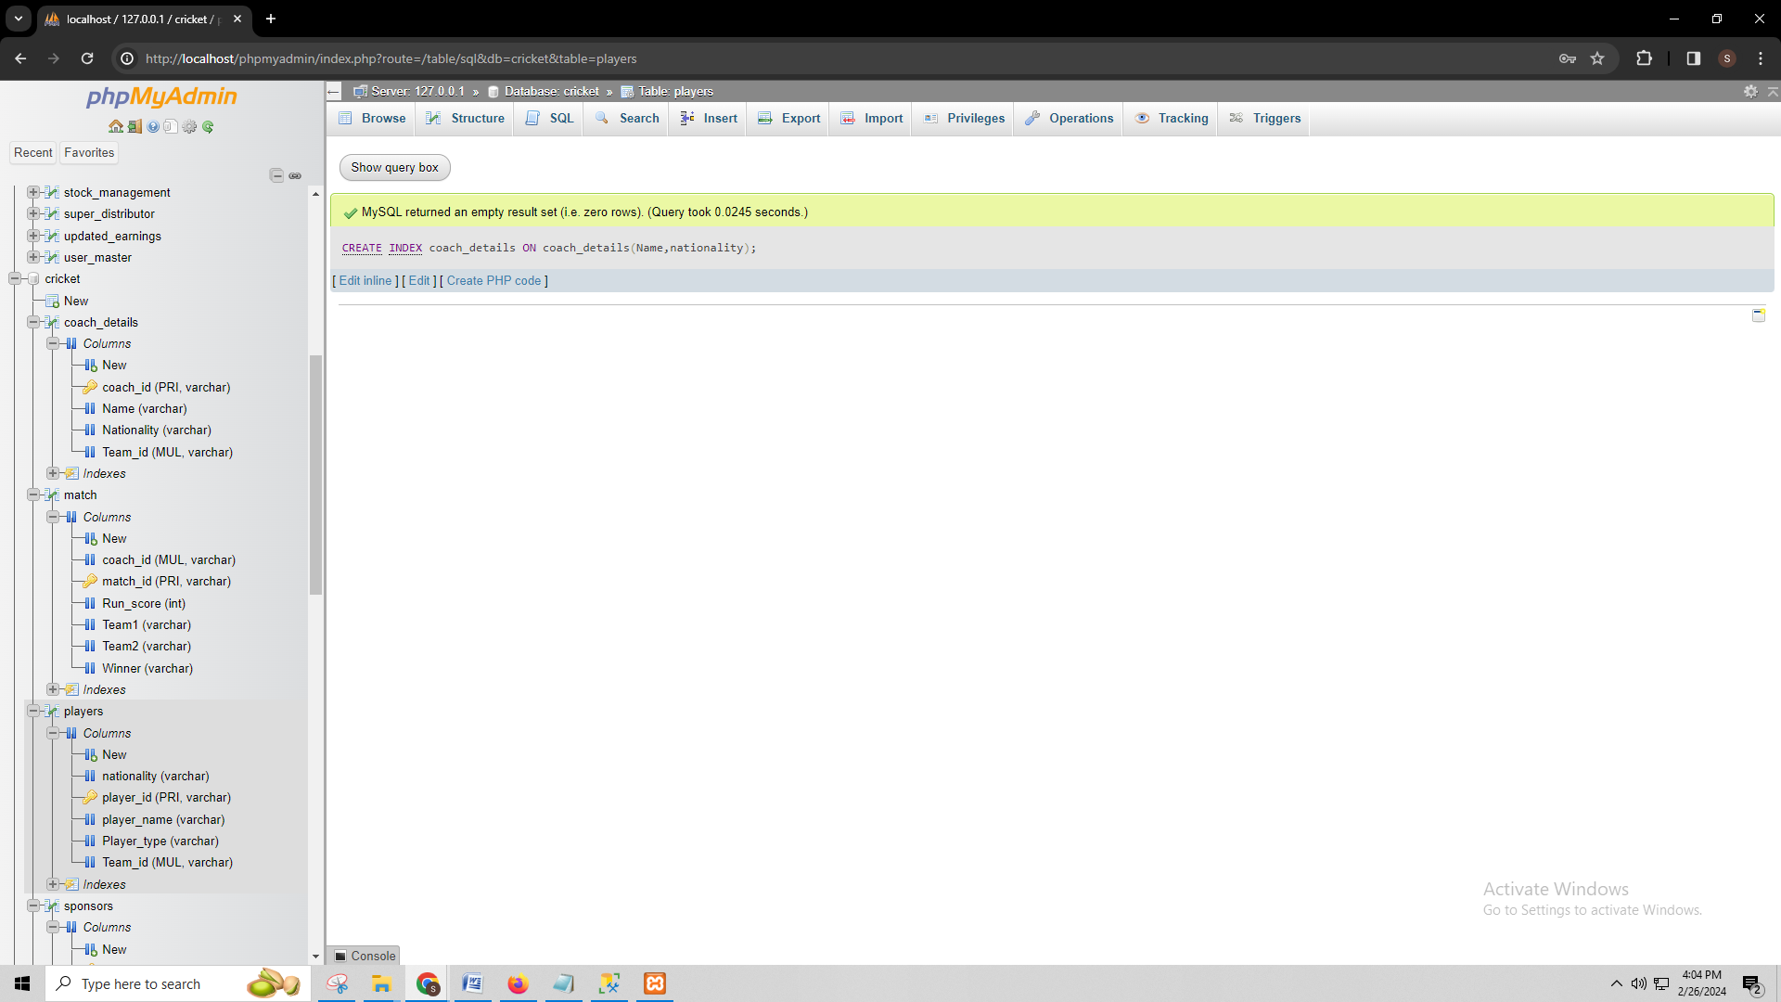

**CREATE INDEX team ON team(Team_name,Team_rank,Total_player);**

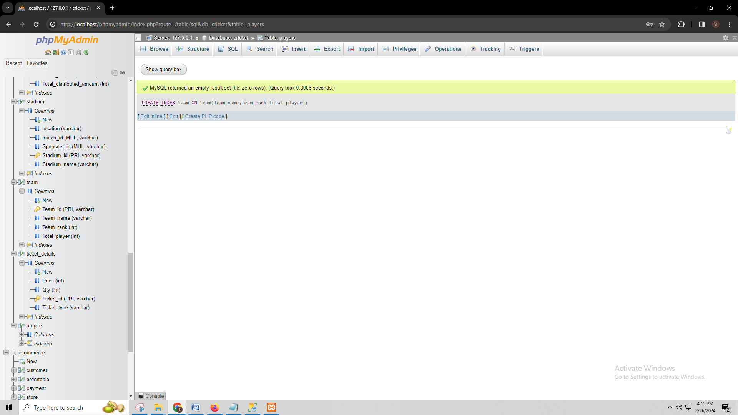

**CREATE INDEX players ON players(player_name,nationality,Player_type);**

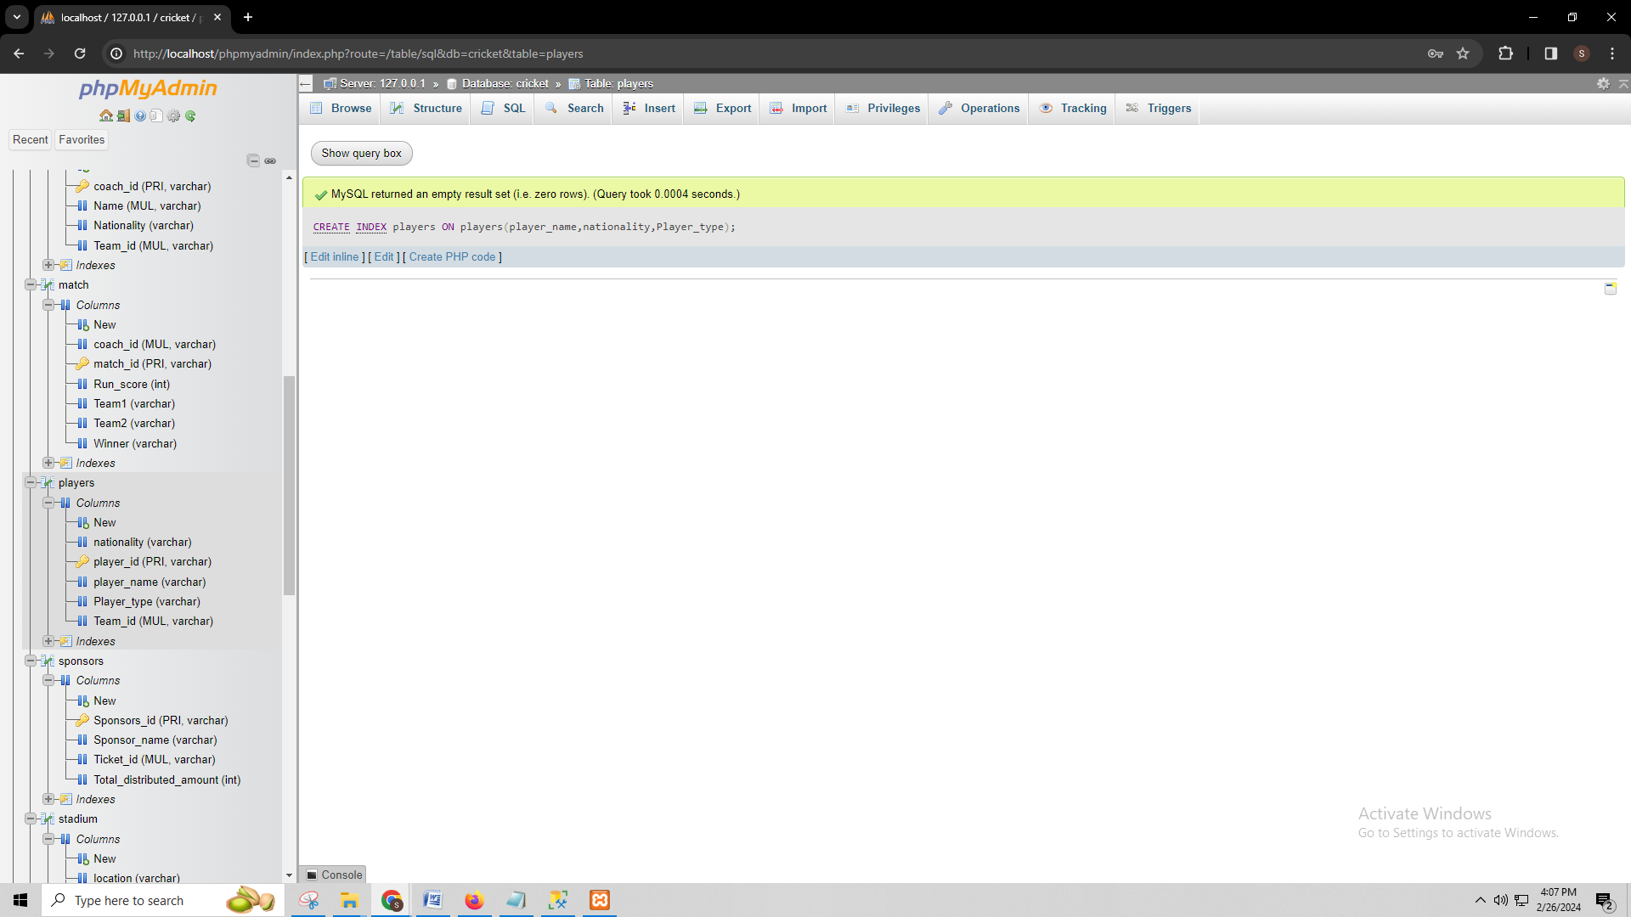

**CREATE INDEX sponsors ON sponsors(sponsor_name,Total_distributed_amount);**

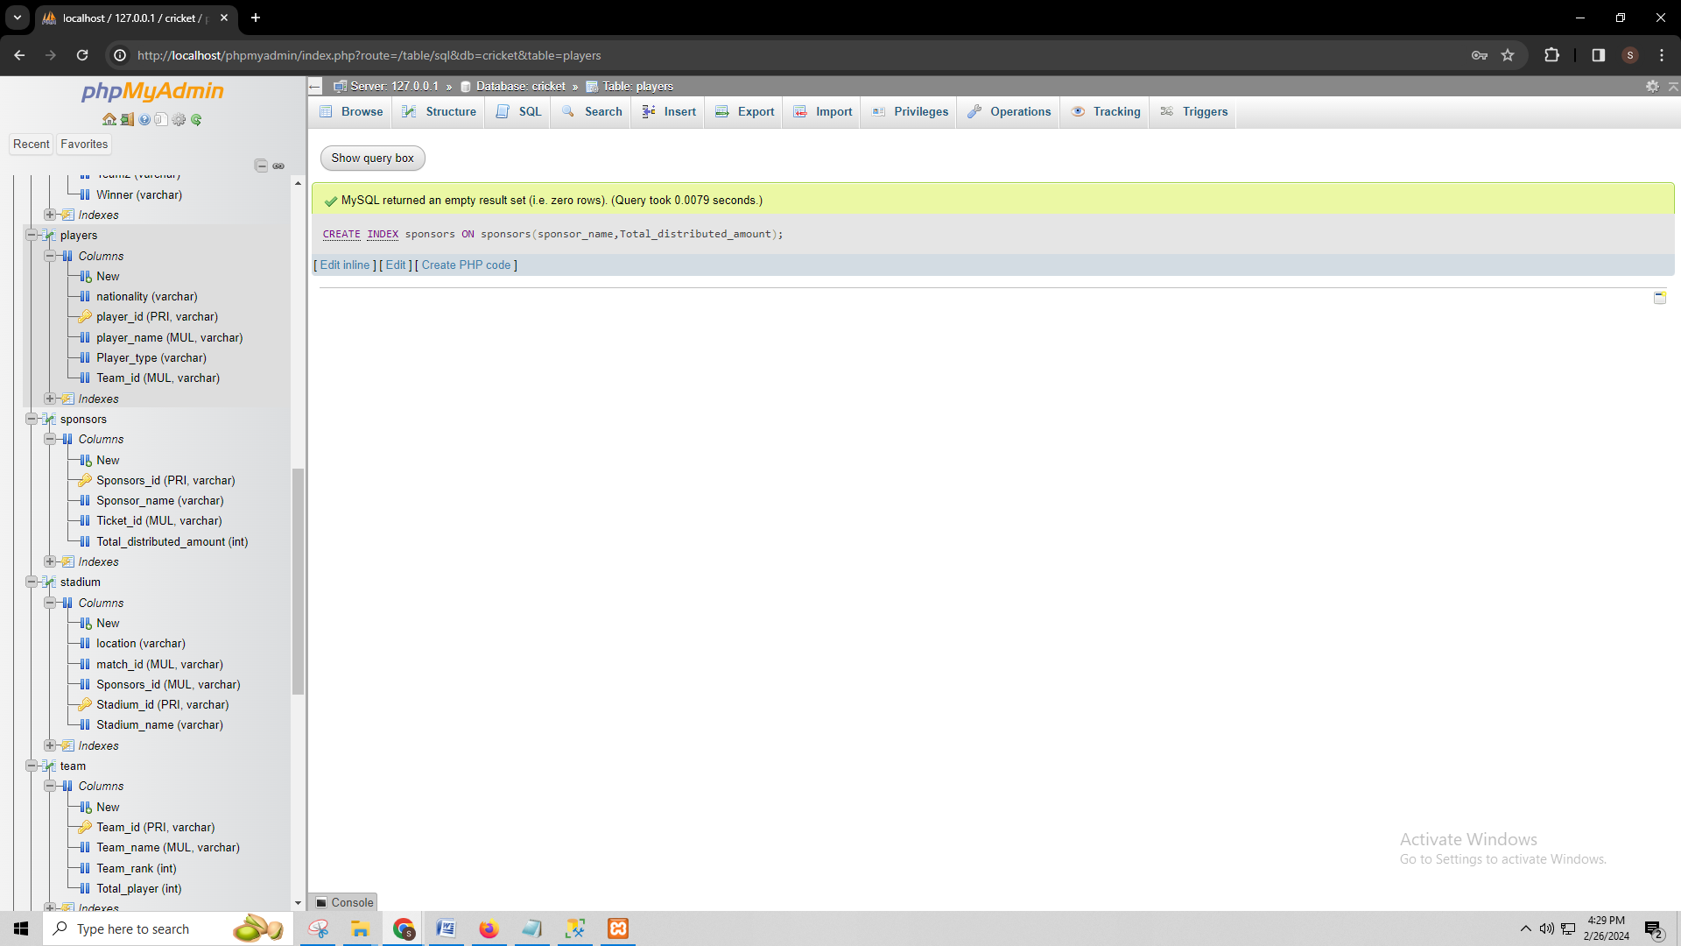

* An index in a database refers to a structure that helps to improve the data retrieval speed on a table. Here I chose various indexes for the table, such four indexes are the Coach details index, Team index, Players index, and Match index.

***Coach details index:*** I chose to build an index on the coach details table on the coach ID and other details of the coach. I chose this index to improve the query performance of a particular coach. This will help the users of the system to find out all the information of a coach on the basis of specific criteria.

***Team index:*** I chose to create a team index to enhance the performance of queries that involve searching for teams by their names, IDs, total players, and total runs.

***Players index:*** I chose this index to improve the efficiency of queries related to individual players, such as retrieving player details or filtering players based on player id, player name, nationality, player types, and team id.

***sponsors index:*** I chose to create an index on the sponsors table for the sponsors_ID. This index will optimize queries that fetch information about specific sponsors, including details like the sponsors_id, Sponsor_name, Ticket_id,Total_distributed_amount.

* **SQL needed to generate the indexes:**
* To demonstrate the performance improvement afforded by the indexes I would implement SQL queries that would involve retrieving data based on the indexed columns, and execution time measurement before and after index creation. I would also observe system resource usage such as CPU and memory usage. I can demonstrate the effectiveness by comparing query execution times and resource usage metrics explicating the shortened data retrieval time and possibly decreased resource consumption due to improved query processing.

# J. Views

create view coach_details_view as select Name,nationality from coach_details;

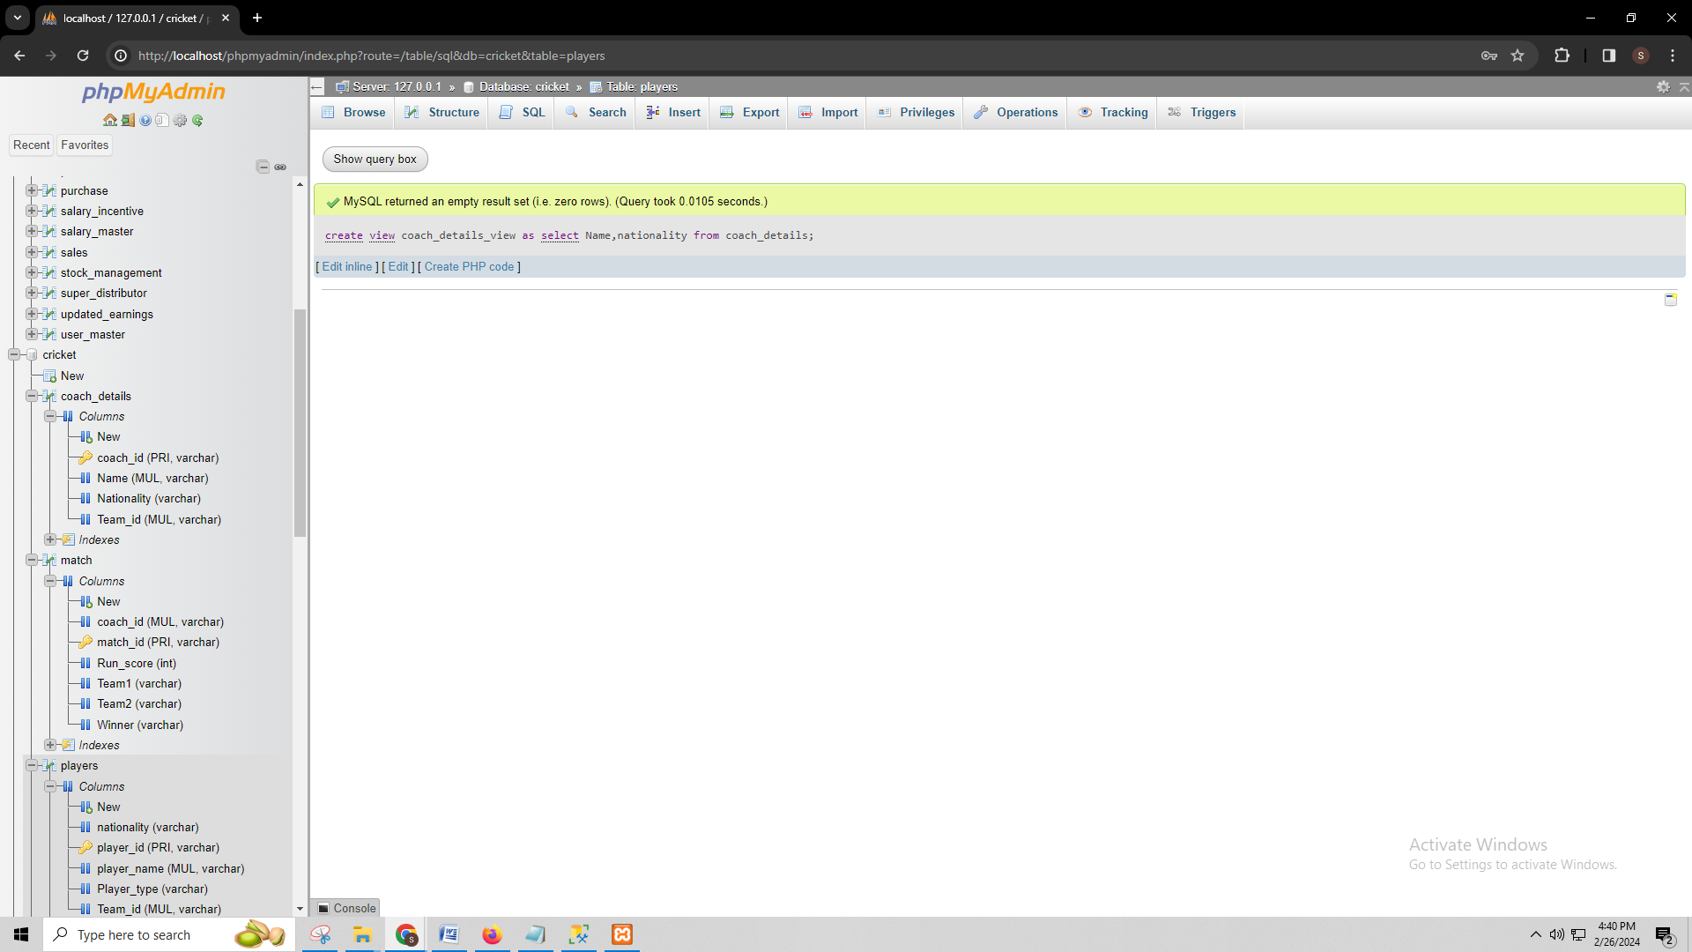

create view players_view as select player_name,nationality,Player_type from players;

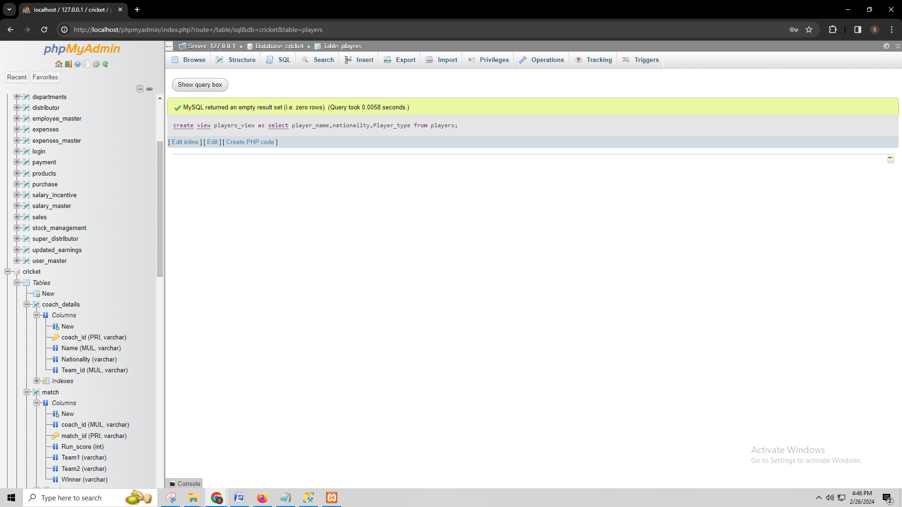

create view sponsors_view as select Sponsor_name,Total_distributed_amount from sponsors;

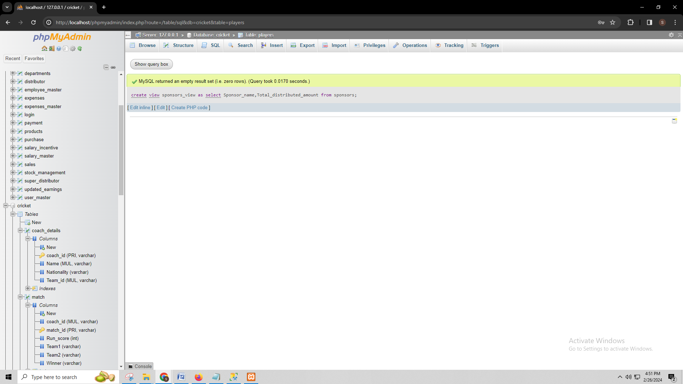

create view stadium_view as select location,stadium_name from stadium;

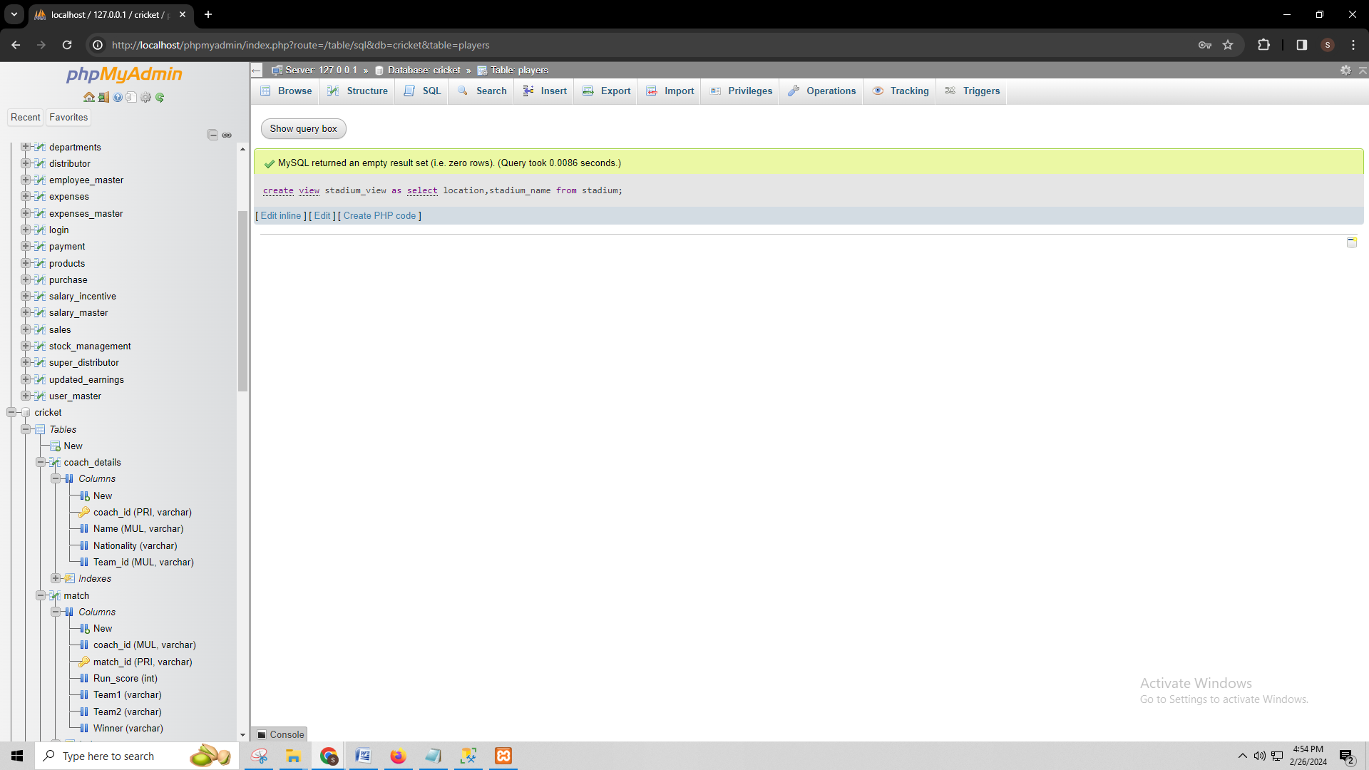

* Each view serves as a valuable addition to my database. Each view provides a simplified and structured representation of complex data. The coach details view provides a simple overview of the coach id, coach nationality, coach name, and team id. Team view represents team details, team id, total players for the team, total scored runs of the teams, etc. Players view in my database helps to get detailed information about the players of the team with their id, names, nationality, player type and team id. Match view is a valuable addition to my database as it presents the match id, team information, winner of the match, run score in the match, and coach id.

# K. Triggers

CREATE TRIGGER team_trigger BEFORE UPDATE ON team FOR EACH ROW BEGIN IF OLD.Team_id = 't5' THEN SET NEW.Team_rank = 5; END IF; END;

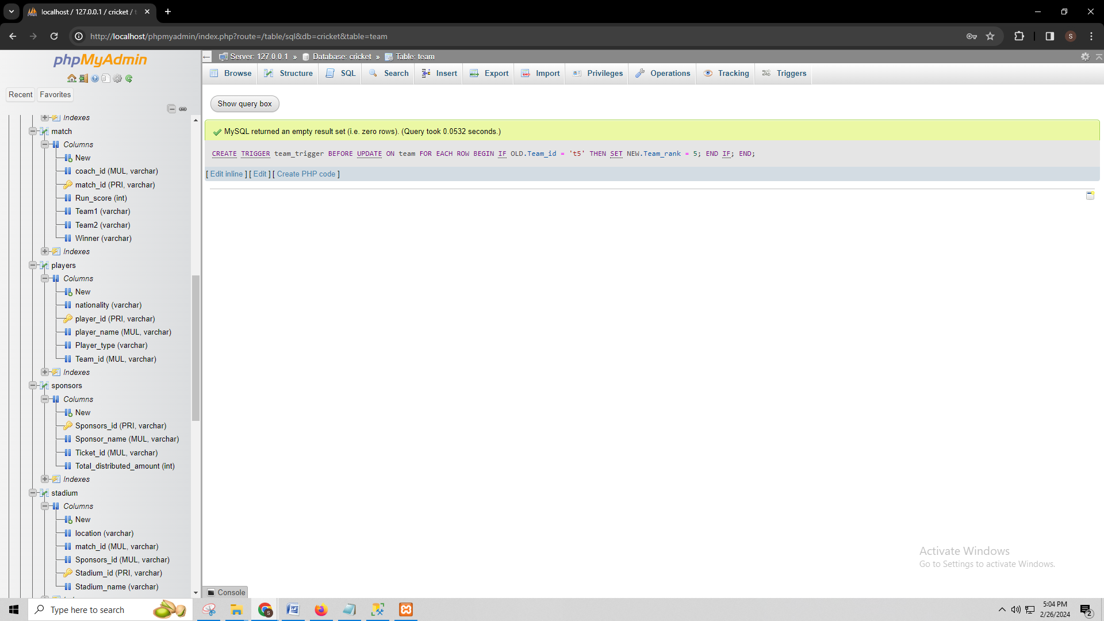

* **Purpose of the trigger:**

The purpose of a trigger to a table execute a particular action in response to certain database events automatically. The operations include insert, delete, or update operations. The purpose of the trigger in the coach details table is to automatically update the information of a coach when any information is changed. The triggers provide data consistency as they maintain accurate information. In the coach details table triggers can update the information automatically if a coach's information is changed such as if a coach moves to a different team, the trigger will detect this change and update the nationality and id attribute, accordingly. By automating this process, the trigger reduces the risk of human error and ensures that the coach's nationality, id always reflect their current team association, enhancing the overall integrity of the database.

# L. Transactions

Transactions are important to ensure ACID behavior. ACID refers to Atomicity, Isolation, and Durability in a database.

UPDATE ticket_details SET price = price + 200 WHERE Ticket_id = 't1';

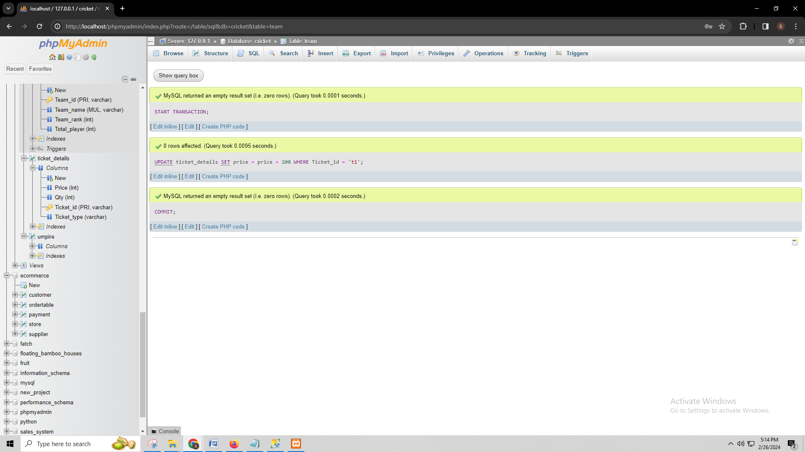

# M. Database Security

*CREATE USER 'user1'@'localhost' IDENTIFIED BY 'password';*

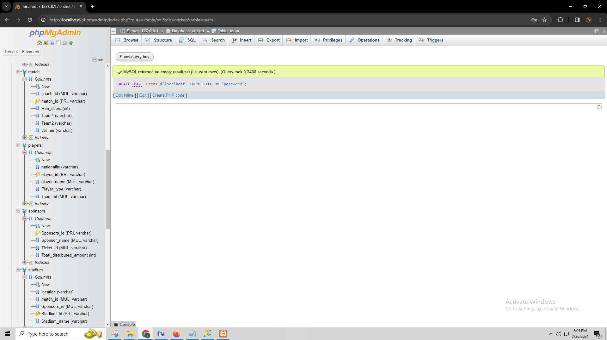

GRANT ALL PRIVILEGES ON *.* TO 'user1'@'localhost';

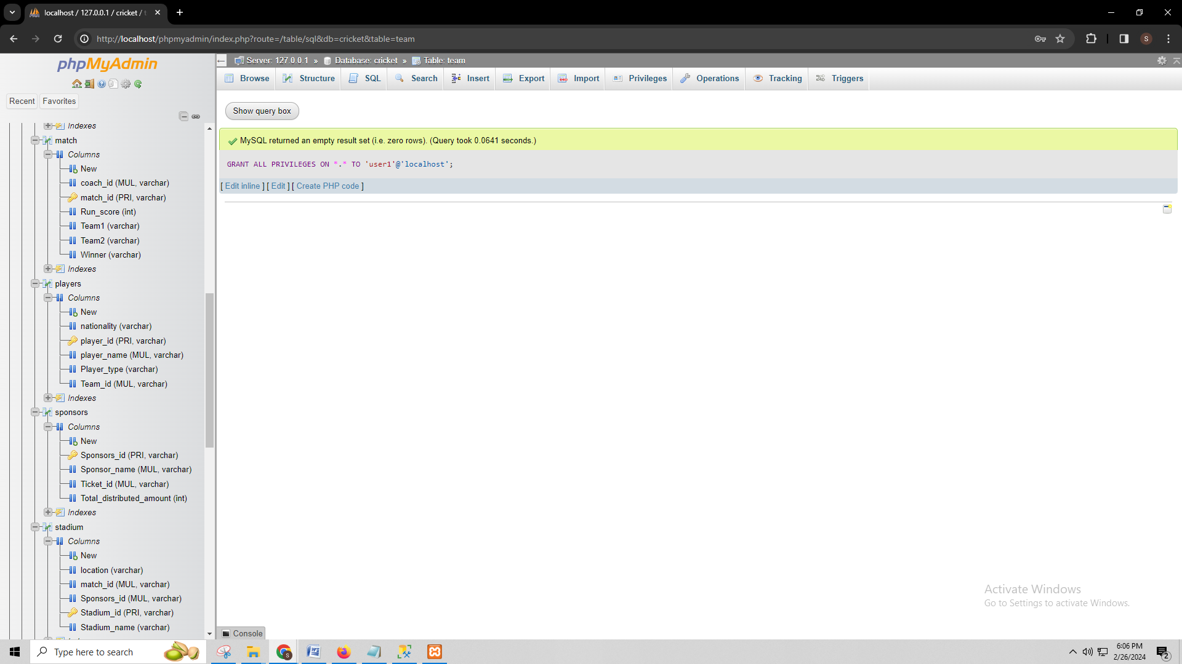

CREATE USER 'user2'@'localhost' IDENTIFIED BY 'pass';

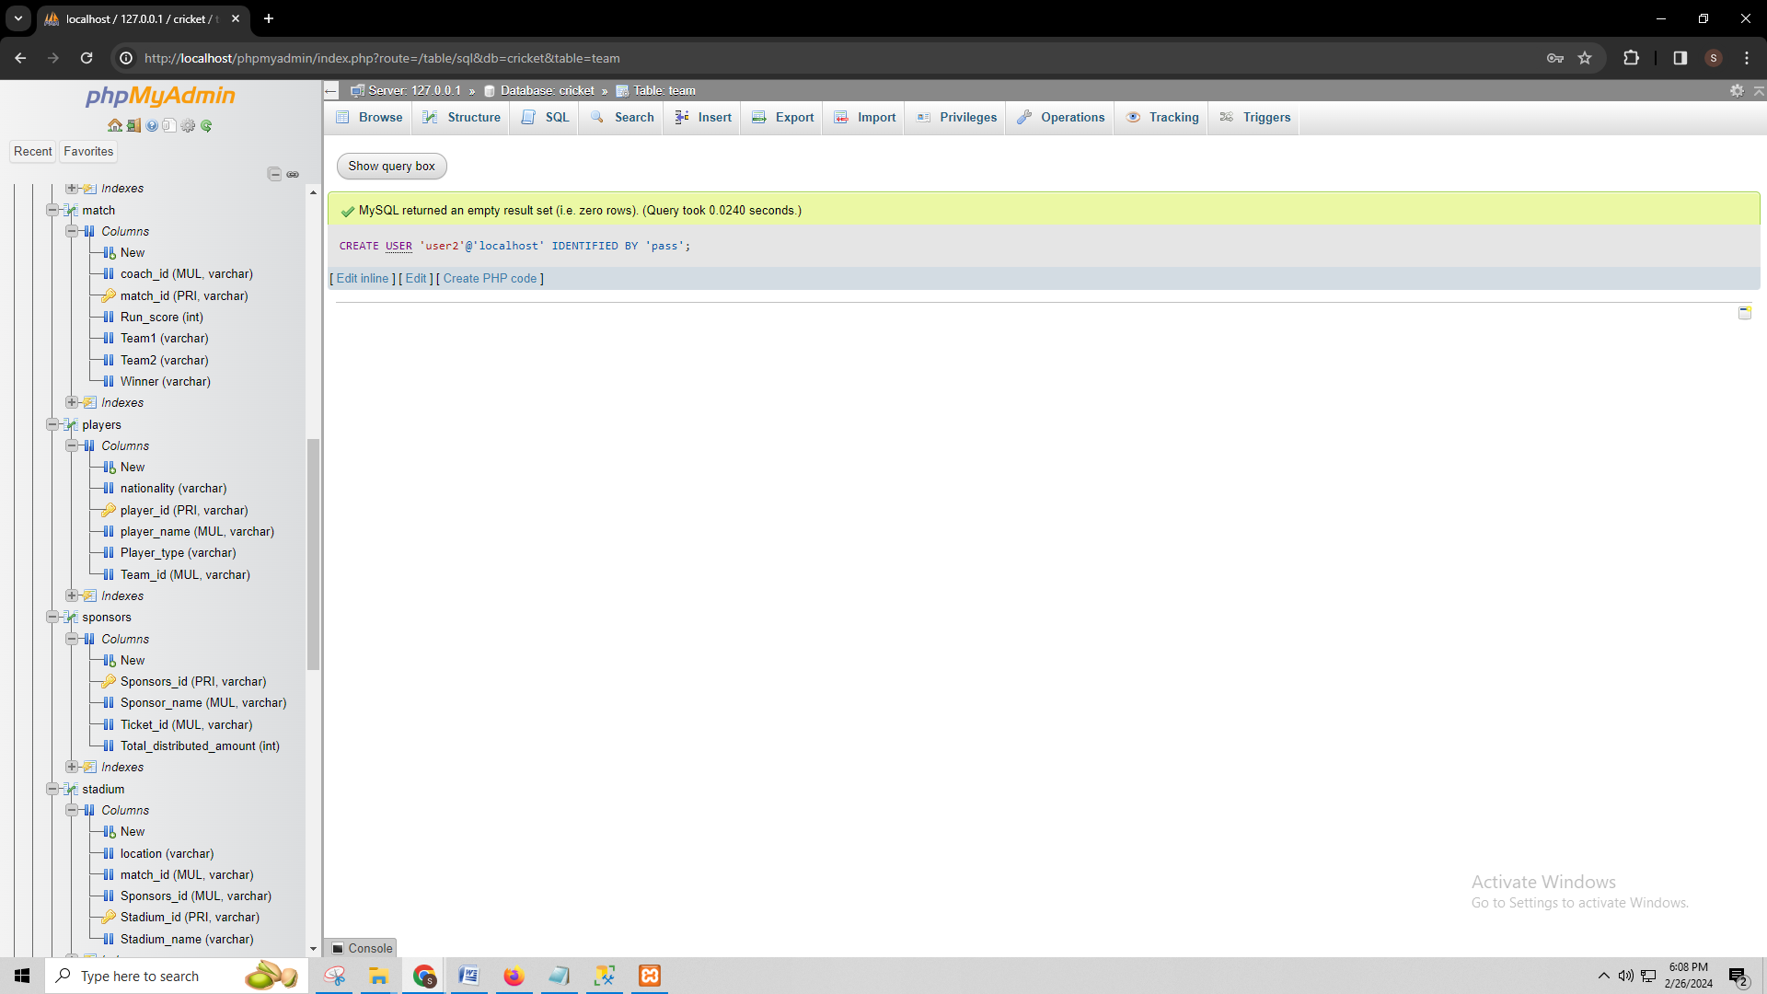

GRANT ALL PRIVILEGES ON *.* TO 'user2'@'localhost';

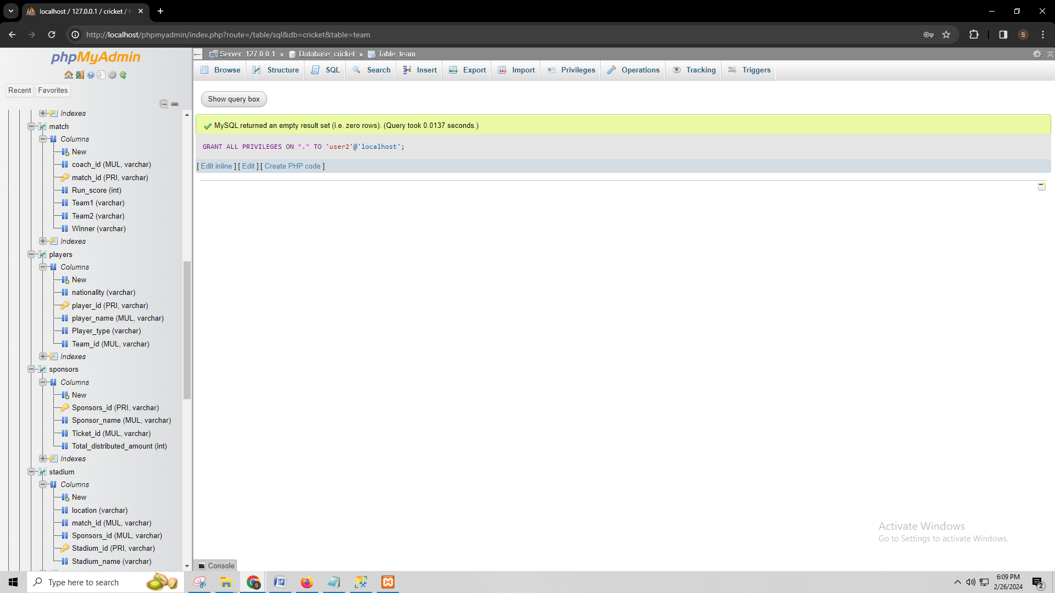

* **Kinds of Users:**

There are different types of users of my sport management system. Here is a detailed description of the users who will use the database and GRANT statements that assign privileges to these different kinds of users:

1. **Administrators:** Administrators have full control over the database and system functionalities. They should have privileges to create, modify, and delete tables, views, triggers, and stored procedures. They also need permission to grant or revoke access to other users.

***GRANT Statement:*** For administrators, I would grant full privileges on all tables with the GRANT ALL PRIVILEGES statement.

1. **Coaches:** Coaches primarily interact with players and match data. They should have read-and-write access to tables such as players, matches, and coach details to input and retrieve information relevant to their teams and matches.

***GRANT Statement:*** For coaches, I would grant SELECT, INSERT, UPDATE, and DELETE privileges on tables related to players, matches, and coach details using the GRANT SELECT, INSERT, UPDATE, DELETE ON statement.

1. **Players:** Players may have limited access to view their own data, including personal information, performance statistics, and team assignments. They should have read-only access to player-related tables and limited access to match data.

***GRANT Statement:*** For players, I would grant SELECT privileges on player-related tables such as players and matches using GRANT SELECT ON.

1. **Umpires:** Umpires require access to match information for scheduling and officiating matches. They should have read-only access to match-related tables and possibly limited access to stadium and sponsor data.

***GRANT Statement:*** Umpires would be granted SELECT privileges on match-related tables like matches and stadiums using GRANT SELECT ON.

1. **Sponsors:** Sponsors may need access to view sponsorship agreements, ticket details, and match information relevant to their sponsorship deals. They should have read-only access to these tables.

***GRANT Statement:*** Sponsors would be provided SELECT privileges on match-related tables like matches and stadiums using GRANT SELECT ON.

1. **Ticketing Staff:** Staff responsible for ticketing and sales need access to ticket details and match information to manage ticket inventory and sales. They should have read and write access to ticket-related tables.

***GRANT Statement:*** For ticketing staff, I would grant SELECT, INSERT, and UPDATE privileges on ticket-related tables with the GRANT SELECT, INSERT, UPDATE ON.

**Day-to-Day Tasks:**

**Day 1:**

I have examined the database design and crucially which are the indexes that effectively increase efficiency. I wish to maintain the indexes on the tables like Coach details, Team, Players, and Match, etc., to improve on the execution of queries and retrieval of data. These indexes have been assigned SQL statements, and execution time measurements and resource usage observations have been made as a plan to show performance improvements through query execution.

**Day 2:**

On day 2, I considered two depending on the requirements of database management as views. I created these views by writing SQL statements and took the screenshots.

**Day 3:**

I focused on implementing a trigger to automate data updates in response to specific events within the database, particularly in the Coach details table. I researched a lot about index and how to do it in my database.

**Day 4:**

I have delved into the importance of transactions in upholding ACID properties within my database. By defining and executing a MySQL transaction, I have shown how transactions ensure atomicity, isolation, consistency, and durability of database operations, thereby safeguarding data integrity and reliability. I provided screenshots capturing the transaction in action, along with a concise explanation to analyze its functionality.

**Day 5:**

I worked on identifying various users' roles within my database system and dound out the GRANT statements of the users that specify their privileges and access levels to the database resources. Screenshots have been taken to showcase how these GRANT statements effectively distinguish among user roles, ensuring appropriate data access and security measures.

**Day 6:**

On day six I checked and rechecked the database. I did performance queries both before and after the creation of the index to test if the performance was good. I validated the implementation of views and triggers to ensure they worked properly. I made sure transactions were installed and updated correctly, preserving database integrity. I reworked user privileges and security access to make sure that all protection measures were fully functional.

**Day 7:**

On day seven, I prepared by document and explanation. I reviewed the clarity, correctness, and completeness of my document. I prepared my document entirely to submit it for grading.